*** KICK IT: A Guide to Smoking Cessation in the Workplace***

**Stress Management Model**

The Stress Response.

1. **Body Response**

* Tension in shoulders
* Knot in stomach
* Headache

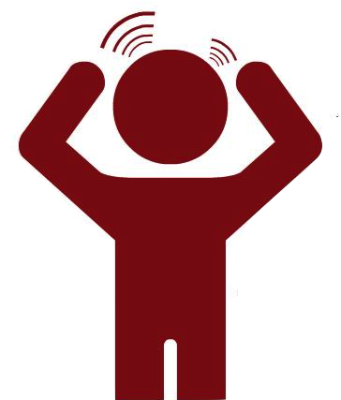

1. **Self-Talk**

* “I never win”
* “Nobody cares about me”
* “She’s not trying hard enough.”

1. **Stressful Situation**

* Argument with partner
* Performance review coming up
* Daughter brings home bad report card

Stress Management.

1. **Address the situation:** do not avoid the situation but simply acknowledge there is a stressor and that you are going to cope with it.
2. **Change the self-talk:** Change the negative “little voice” in your head to a positive “little voice.”
3. **Listen to your body:** Where is your body reacting? You may decide to go for a walk, pound a pillow for awhile, practice deep breathing or lie down.

Stress Tips

* Learn to laugh. Laughter is healthy and learn to use and recognize humour throughout the day.
* Take a break when you feel pressured to finish a job.
* At the end of each day, think about what you have completed and *not* what you still have to do.
* Cry if you’ve reached a point where you feel it’s the only thing that will help.
* Do one thing at a time.
* Use calendars and lists to keep track of things you have to do. Once a task is done, cross it off your list.
* Spend more time in natural light and sunshine.
* Get active. Physical activity helps relieve stress.
* Eat well. Eat regular, balanced meals along with healthy snacks (nuts, fruit, yogurt).
* Sleep earlier, which will allow you to wake up earlier. Spend the extra time in the morning to prepare for your day. This will allow you to be relaxed and capable of handling the stresses that may come up.

Source: [www.cpha.ca](http://www.cpha.ca)