*** KICK IT: A Guide to Smoking Cessation in the Workplace***

**What would you Buy?**

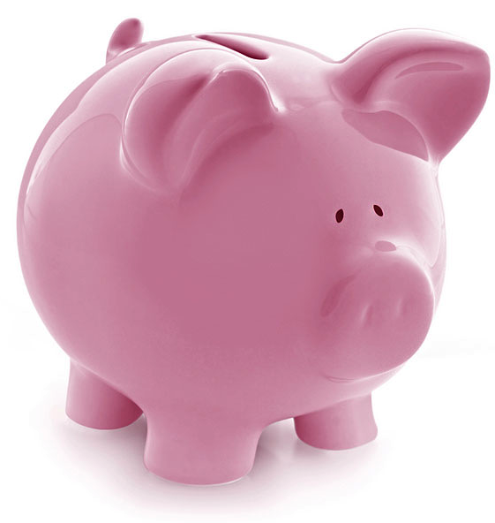

A great benefit to quitting smoking is the money you save from cigarettes! In the second column of the chart, write down the amount you spend on cigarettes at 1 day ending with 10 years. For example, if you smoke a pack a day and each pack is $7.00, in one day you would save $7.00, in one week you would save $49.00 and in one month you would save $196.00. In the third column, write down what you could buy … A vacation? A nice dinner with your partner? A gym class?

|  |  |  |
| --- | --- | --- |
| Time | Amount spent on cigarettes | What could you buy? |
| 1 day |  |  |
| 1 week |  |  |
| 2 weeks |  |  |
| 3 weeks |  |  |
| 4 weeks |  |  |
| 2 months |  |  |
| 3 months |  |  |
| 4 months |  |  |
| 5 months |  |  |
| 6 months |  |  |
| 1 year |  |  |
| 2 years |  |  |
| 5 years |  |  |
| 10 years |  |  |

Source: [www.gosmokefree.gc.ca](http://www.gosmokefree.gc.ca)