*** KICK IT: A Guide to Smoking Cessation in the Workplace***

**10 Ways to Help a Friend Quit Smoking**

Congratulations! If your friend has asked you to be his/her support buddy to help quit smoking, you get to be part of one of the most important decisions to improve his/her health.

1. **Ask.** Say, “how can I help you?” Make yourself available as much as possible, especially during the first few days.
2. **Patience.** People who quit smoking generally experience physical and psychological withdrawal symptoms. These usually peak within 48 hours but may persist for as long as 4 weeks. Seek to first understand, not to be understood.
3. **Listen.** Do not preach or counsel. Hostility and irritability is part of the withdrawal process and it is important you be an active listener!
4. **Seek.** Suggest he/she seeks help (help line, other resources, or ask a doctor).
5. **Invite**. Invite him/her to join you in activities that are not associated with smoking such as walking, swimming, going to the theatres, libraries, grocery shopping and department stores.
6. **Offer.** Offer practical support such as taking his/her kids for a few hours or helping with difficult work situations.
7. **Stash.** Keep a stash of smoking substitutes on hand. People who quit smoking miss the satisfaction of handling and inhaling a cigarette. Keep a stash of gum, mints, toothpicks and straws on hand.
8. **Persistence.** Persist if your friend has a relapse. Sometimes it takes five or six more attempts before a smoker quits for good. If you persist in your encouragement and to try again, they may also persevere to try again.
9. **Celebrate.** Help mark significant milestones such as three days, one week, or one month of being smoke-free. Go out for a meal or treat him/her to a favorite treat!
10. **Reinforce.** Reinforce the benefits of staying smoke-free. Encourage your friend to use the money he/she has saved to purchase something special.

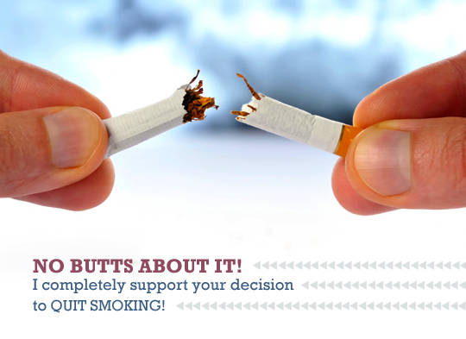

Source: [www.gosmokefree.gc.ca](http://www.gosmokefree.gc.ca)