*** KICK IT: A Guide to Smoking Cessation in the Workplace***

**What’s the Quit Method best for *ME*?**

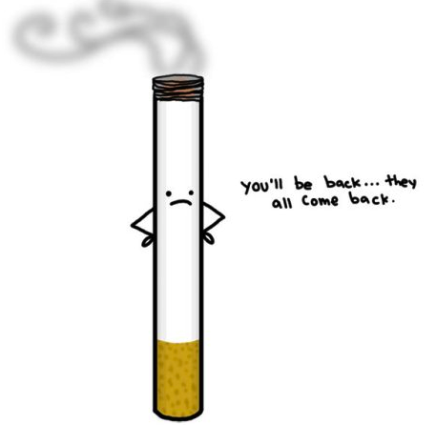

**3 THINGS.**

1. **Recovery or withdrawal symptoms are what people who quit fear most.**
2. Physical symptoms usually last a week at most, and they’re not as severe as the recovery symptoms from alcohol or many street drugs.
3. Recovery symptoms are only temporary and will pass whether you smoke or not!

Would I Quit Suddenly?

Are you someone who likes to do something all in one go? This would look like: taking the time to understand where and why you smoke, mental preparation to break the patterns and deal with withdrawal, then stopping all at once.

Would I Cut Back Gradually?

Are you someone who likes to do things in little steps or increments? This would look like: slowly reducing the amount you normally smoke as you move closer to your quit date. Cutting back allows you to get a sense of what it will be like to quit for good. It allows you to solve a few challenges at a time, instead of all at once.

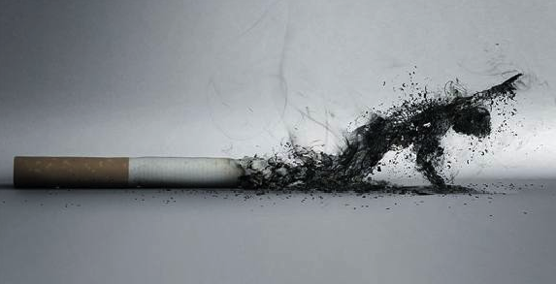

Do I really need it?

The easiest cigarettes to cut out are the ones you do not need! Each time you reach for a cigarette, ask yourself, “Do I really need it?” Consciously stop yourself and ask that question. **Wait 5 or 10 minutes** before acting on your urge to smoke.

Ration.

Start to ration your cigarettes by carrying only enough to get you through the day and refusing to get more. Every day or two, reduce that amount. Cut down as far as you can. Try delaying your first cigarette by at least two hours and eliminating cigarettes during afternoon breaks or after dinner.

Source: [www.gosmokefree.gc.ca](http://www.gosmokefree.gc.ca)