The Power of Positive Thinking
Week 3: Peaks and Valleys

Peaks are moments when you appreciate what you have.
Valleys are moments when you long for what is missing.


Like a healthy heartbeat …
“Peaks and Valleys are not just the good and bad times that happen to you. They are also how you feel inside and response to outside events.”
(Johnson, p. 44)

your personal peaks and valleys are an essential part of a normal, healthy life.

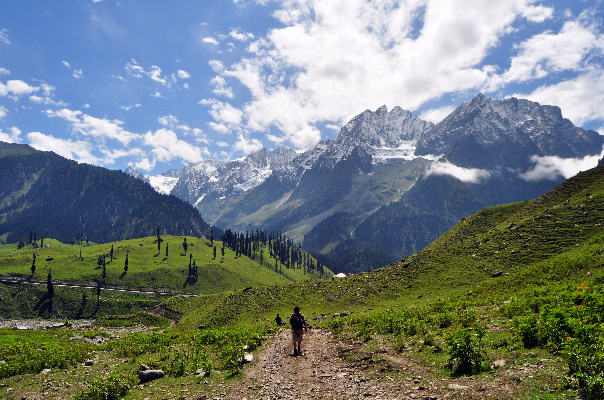
Peaks and Valleys are CONNECTED
The errors you make in today’s good times create tomorrow’s bad times. And the wise things you do in today’s bad times create tomorrow’s good times. Valuable lessons can be learned in the Valley!

When using a Peaks and Valleys approach during bad times, things get a lot easier when you see the bigger picture and concentrate on what matters most (Johnson, 2009).

The Value in Valleys
- The pain in a valley can wake you up to a truth you have been ignoring.
- How you manage your valley determines how soon you reach your next peak.
- If you do not learn in a valley, you can become bitter. If you learn something valuable, you can become better.
- Getting out of a valley occurs when you choose to see things differently.
“The most common reason people leave a peak too soon is arrogance, disguised as confidence. The most common reason people stay in a valley too long is fear, disguised as comfort.” (Johnson, p.51)

To stay on a peak longer… be humble and grateful. Do more of what got you there. Keep making things better. Do more for others. Save resources for your upcoming valleys.

Want more help? Contact your EAP at ________________________

Johnson, Spencer. (2009). Peaks and valleys: Making good and bad times work for you - At work and in life. New York: Atria Books

