Brain Boosters
Brain Health
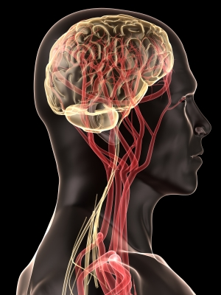
We often think that “staying fit” refers to the neck down. But, the health of your brain plays a critical role in almost everything you do such as: thinking, feeling, remembering, working, playing, sleeping.

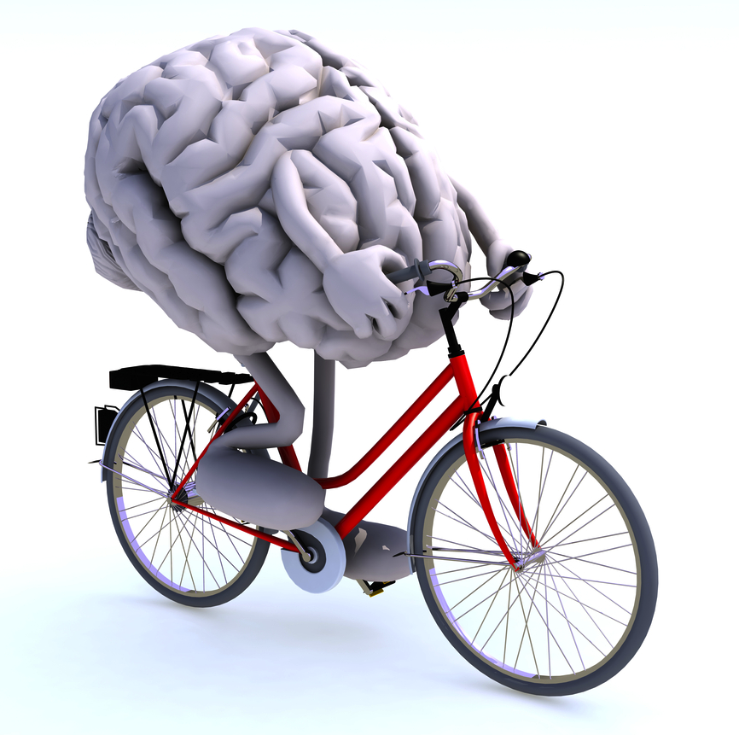
There are things YOU CAN DO to help keep your brain healthier as you age. This may also reduce your risk of Alzheimer’s disease and dementia.

Brain-Healthy Life Choices
- Stay physically active
More evidence is showing that physical exercise does not have to be strenuous or require a long duration. It is most effective when done regularly, and in combination with a brain-healthy diet, mental activity and social interaction.
Aerobic exercise improves oxygen consumption (which benefits brain function), and reduces brain cell loss in elderly subjects. Examples: walking, bicycling, gardening, tai chi, yoga. Combine it with mental activity by plotting your route, observing traffic signals, making choices. Combine it with social activity by doing something with family or friends!


- Eat a brain healthy diet
- Manage your body weight. Studies have shown that obese individuals were twice as likely to develop dementia in later life. Tip: Adopt an overall food lifestyle (not a short-term diet), and eat in moderation.
- Lower fat and cholesterol. Research shows that those with high cholesterol and high blood pressure had six times the risk of dementia. HDL (or “good”) cholesterol may help protect brain cells. Tip: Use mono- and polyunsaturated fats (e.g., olive oil), bake or grill food instead of frying.
- Increase your intake of protective foods. Try eating:
  - Dark-skinned veggies: kale, spinach, brussels sprouts, beets.
  - Dark skinned fruits: prunes, berries, plums, oranges, red grapes.
  - Cold water fish: halibut, mackerel, salmon, trout and tuna.
  - Nuts with vitamin E: almonds, pecans and walnuts
- Vitamins may be helpful. Vitamin E (or vitamin E with C), vitamin B12 and folate may be important in lowering your risk of developing Alzheimer’s.

- Remain socially active
One study reported that leisure activities that combine physical, mental and social activity are the most likely to prevent dementia.
Other research found that sports, cultural activities, emotional support and close personal relationships together appear to have a protective effect against dementia.

Stay socially engaged in activities that stimulate the mind and body:
- Stay active in the workplace
- Volunteer in community groups and causes
- Join bridge clubs, square dancing clubs or other social groups
- Travel

- Stay mentally active
Those with higher levels of education may have protection against Alzheimer’s due to stronger brain cells and connectivity. Well-educated individuals can still get Alzheimer’s, but symptoms may appear later.

You do not have to make extreme lifestyle changes or sign up for school again, but start with something small, like a daily walk. After a while, add another small change.
Keep your brain active every day:
- Stay curious and involved – commit to lifelong learning
- Read, write, work crossword or other puzzles
- Attend lectures and plays
- Enroll in courses at your local adult education center, community college or other community group
- Play games
- Garden
- Try memory exercises



Take Home Message
- Brain health is critical for daily functioning like thinking, feeling, working.
- Stay physically active doing various kinds of aerobic activity.
- Eat foods lower in fat and cholesterol. Choose dark-skinned vegetables and fruit, nuts, and fish.
- Stay socially engaged while doing leisure activities.
- Do your best to combine physical activity, healthy diet, social activity, and mental activity for added protection against dementia and Alzheimer’s!
- Incorporate small ways to keep you mentally sharp each day.

Source: Alzheimer's Association. (2014). Brain Health. Retrieved from http://www.alz.org/

