The Power of **Positive** Thinking

Week 2: Be Proactive

The first habit in, “The 7 Habits of Highly Effective People” by Steven Covey, reveals the secret of *how* to achieve positive thinking – **being proactive.**

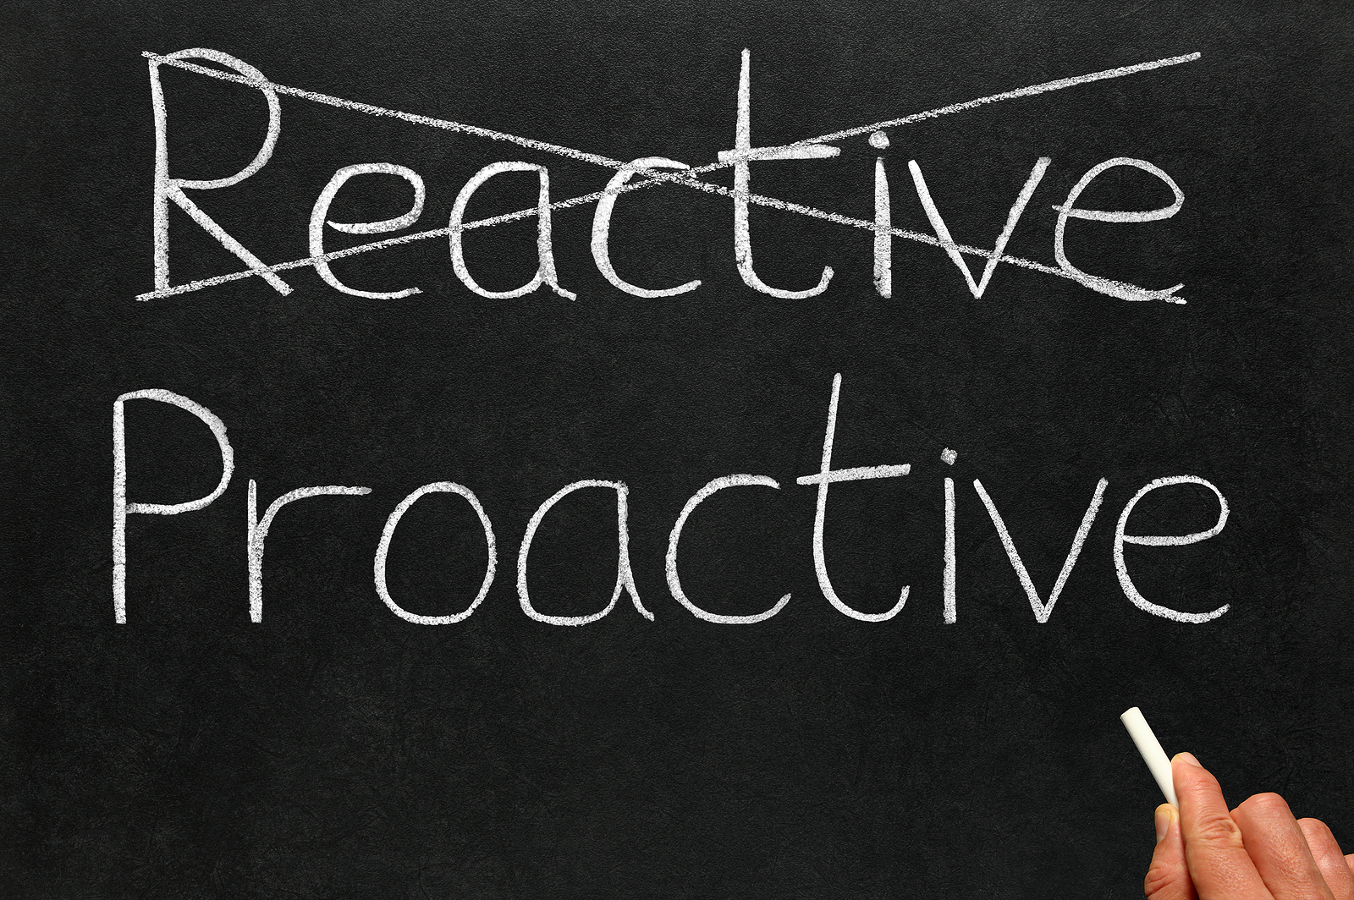

**Be ~~Reactive~~ Proactive**

Being proactive means you are “response-able.” You don’t blame genetics, circumstances or conditions. You choose your behaviour.

On the other hand, being reactive means you try to find external sources to blame your behaviour. For example, bad weather can easily be what you blame if you’re in a bad mood.

One of the most important things you choose is what you say. A proactive person uses, “I can,” “I will,” “I prefer.” A reactive person uses, “I can’t,” “I have to,” “If only.”

**What will you say?**

Do you focus on the **“haves”** or **“bes”**?

**Circle of Concern** is filled with “haves” = **Reactive Focus**

* 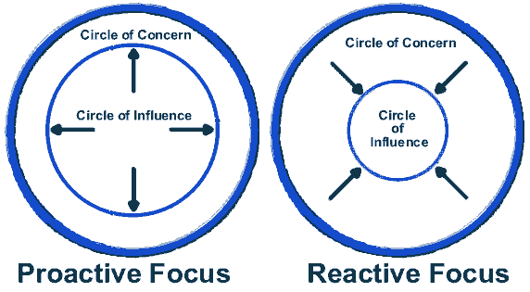If I could just have more time to myself…
* I’ll be happy when I have the house paid off …
* If only I had a more patient husband …

*…Things we have no real control over*

**Circle of Influence** is filled with “bes” = **Proactive Focus**

* I can be more patient
* I can be more loving
* I can be more diligent

*…Things we can do something about*



Instead of reacting to or worrying about things you have no control over, focus your time and energy on things you *can* control: health, children, problems at work, etc. This means you change from the **inside out**.

**Want more help? Contact your EAP at ________________________**

Covey, S.R. (2004). *The 7 habits of highly effective people: Powerful lessons in personal change.* New York: Free Press.