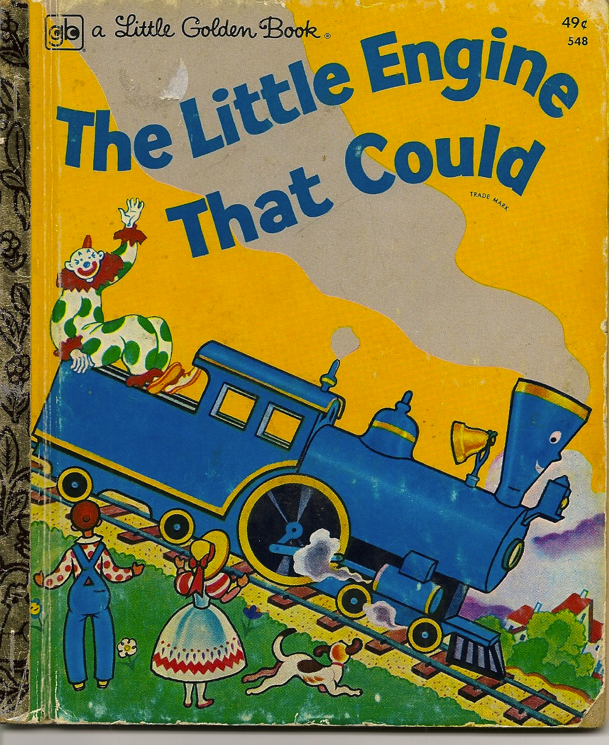The Power of **Positive** Thinking – Week 1: Is It True?

“I think I can, I think I can …”

We may have believed this as a kid, but do we now?

**Positive Thinking Defined**

Holding positive expectancies for one’s future.

These positive expectancies = optimism.

|  |  |
| --- | --- |
| **Optimism can improve your psychological well-being** | **Optimism can improve your physical well-being** |
| Optimistic people routinely maintain a **higher level of subjective well-being during times of *stress* than people who are less optimistic** (Aspinwall & Taylor, 1992; Carver & Gaines, 1987). | Ever had a loved one suffer from a disease? You’ll recall how difficult it was to stay positive.  **Good news.** Patients who are more optimistic are less likely than pessimistic patients to suffer from physiological complications, and more likely to have faster recovery, resume vigorous exercise, work full time, and return to their normal lifestyles (Scheier et al., 1989).  **…there is hope to being hopeful.** |

**The Power of Positive Thinking Lies in an Optimistic Attitude**



**On the Road to Positive Thinking …**

* Think about **how** you can **cope** with stress. What are direct steps you can take to solve an issue?
* Accept the reality of stressful situations and try to make the best of the bad situations.
* Don’t be a pessimist. Pessimists tend to avoid dealing with problems, and quit trying when difficulties arise during stressful events.
* Words of affirmation and positive self-talk can reverse the damaging effects of negative thinking. Build yourself and others up and encourage them.

**Want more help? Contact your EAP at ________________________**

Carver, C.S., & Gaines, J.G. 1987. Optimism, pessimism, and postpartum depression. *Cognitive Therapy and*

*Research, 11,* 449-462.

Scheier, M.F., & Carver, C.S. 1992. Effects of optimism on psychological and physical well-being: Theoretical

overview and empirical update. *Cognitive Therapy and Research, 16,* 201-228.

Scheier, M.F., & Carver, C.S. 1993. On the power of positive thinking: The benefits of being optimistic. *Current*

*Directions in Psychological Science, 2*(1), 26-30*.*