The Power of **Positive** Thinking

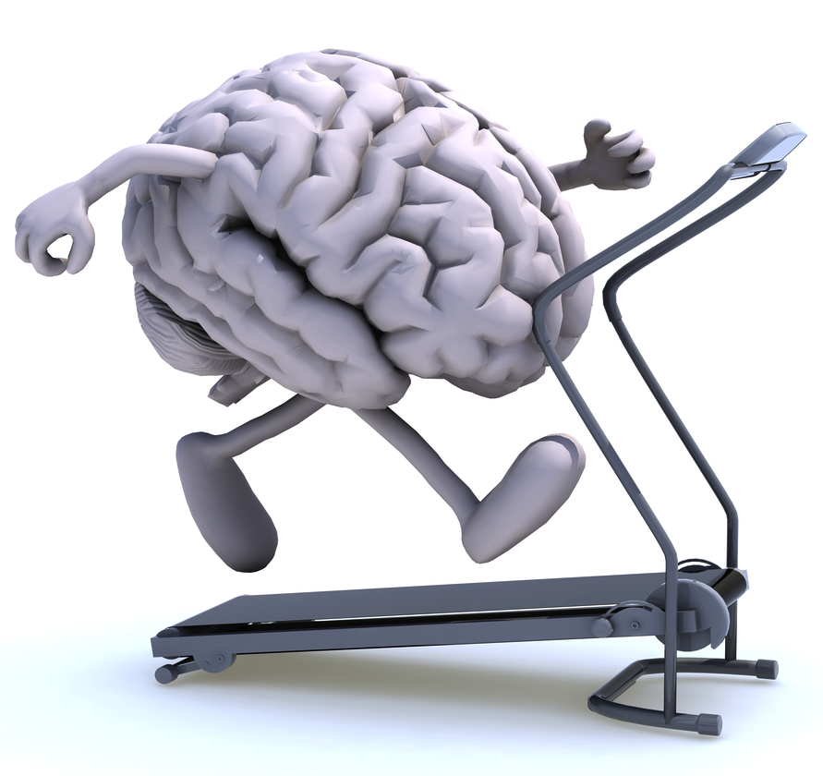Week 4: Healthy Body = Healthy Mind

**Exercise Proven to Reduce Anxiety and Depression**

Aerobic exercise (e.g., jogging, swimming, gardening, dancing) has been proven to reduce anxiety and depression. It is suggested that exercise increases blood flow to the brain (hypothalamus region) and thus, influences our response to stress (Guszkowska, 2004). Exercise also improves self-esteem and cognitive function (Callaghan, 2004).

**How much Exercise?**

**30 minutes at moderate intensity (e.g., brisk walking) for 3 days a week.** Break up these 30 minutes into three 10-minute bouts to get the same benefits (Sharma, Madaam, & Petty, 2006).

*Find activities you enjoy and work them into your schedule. Be realistic and have fun!*

|  |  |
| --- | --- |
| 1. Improved sleep | 1. Increased energy and stamina |
| 1. Increased interest in sex | 1. Reduced tiredness that can increase mental alertness |
| 1. Better endurance | 1. Weight reduction |
| 1. Stress relief | 1. Reduced cholesterol and improved cardiovascular fitness |
| 1. Improvement in mood |

**9 Reasons why you should Exercise** (Sharma, Madaam, & Petty, 2006)

**Don’t Forget to Eat, Drink, and Sleep Right** (Canadian Mental Health Association, 2012)

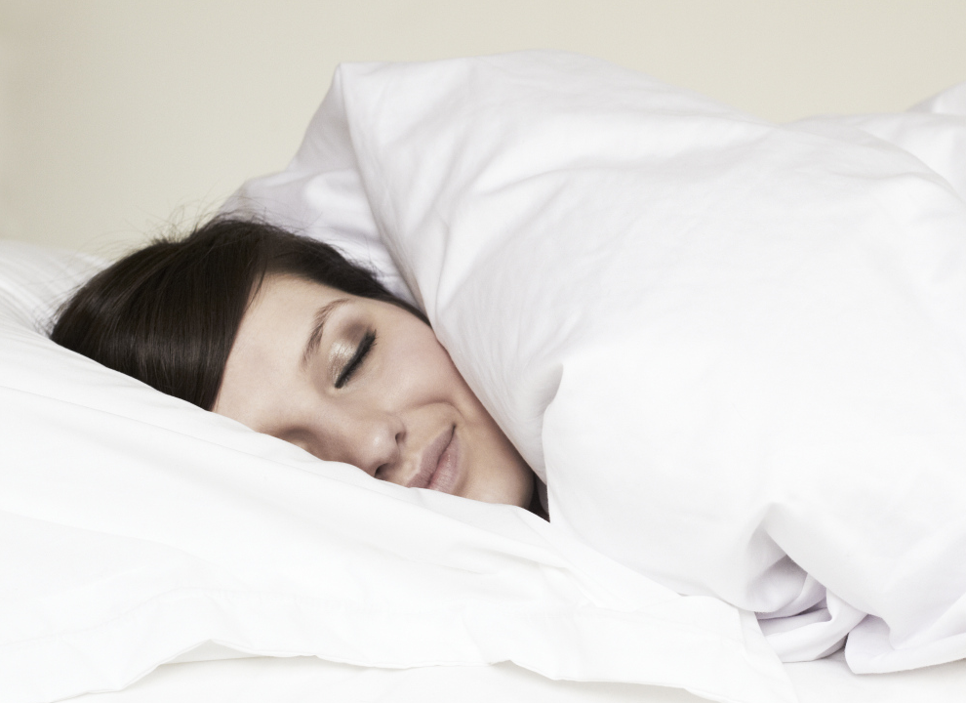Evidence suggests that healthy eating can keep your mood and energy levels steady. Try incorporating more unsalted **nuts, fish, fruits, and vegetables** into your diet.

Caffeinated drinks (e.g., coffee, black tea, cola) can temporarily give you more energy, but it can also make you feel nervous, irritable or restless. **Do not forget to drink water**! It replenishes brain cells and helps fight fatigue.

Good-quality **sleep rests the brain and repairs and replenishes brain cells**. This helps our mood, decision-making and social interactions, whereas inadequate sleep can make you feel anxious, sad, or stressed. Try to go to bed and wake up at the same time every day.

**Want more help? Contact your EAP at ________________________**

Callagan, P. (2004). Exercise: A neglected intervention in mental health care? *Journal of Psychiatric and Mental Health Nursing.*

*11(4),* 476-483.

Canadian Mental Health Association. (2012). Improving Mental Health. Retrieved from <http://www.cmha.bc.ca/>

Guszkowska, M. (2004). Effects of exercise on anxiety, depression, and mood. *Psychiatria Polska. 38(4), 611-620.*

Sharma, A., Madaan, V., & Petty, F.D. (2006). Exercise for mental health. *The Primary Care Companion to the Journal of Clinical*

*Psychiatry.* 8(2), 106.