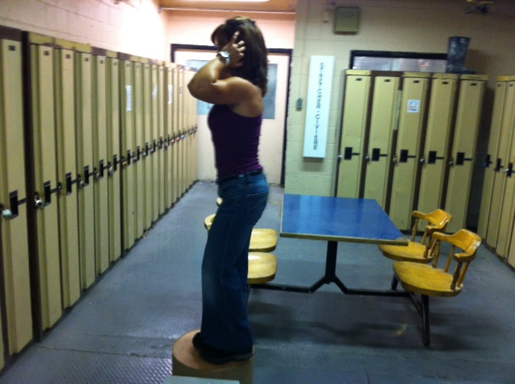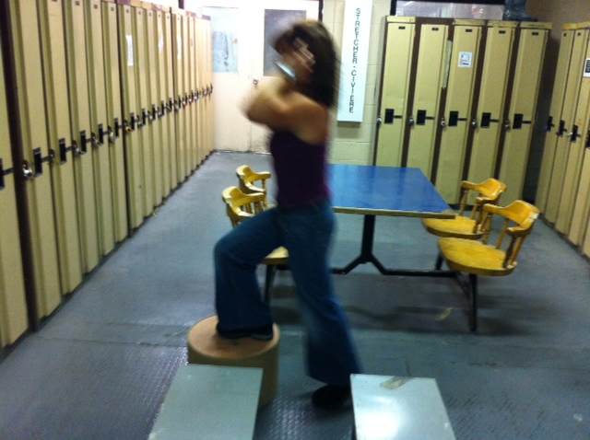

Step Ups (Lower Elevation)

**Instructions:**

*Preparation:*

Stand facing side of low platform.

*Execution:*

Place foot of first leg on platform. Stand on bench by extending hip and knee of first leg and place foot of second leg on platform. Step down with second leg by flexing hip and knee of first leg. Return to original standing position by placing foot of first leg to floor. Repeat first step with opposite leg alternating first steps between legs.

*Rep Guidelines:*

**Muscle Group Targeted:**

*Legs, Glutes*

**Caution!!**

* If you are unsure of any of the exercises in the Mill Workout, see your onsite consultant for review!
* In hot conditions, avoid exertion
* Remember to continue breathing, exhaling on exertion (most difficult part of exercise).
* Exercise should never be painful! If the exercise causes pain (not just discomfort), stop immediately!

Presents:

**The Mill Workout**