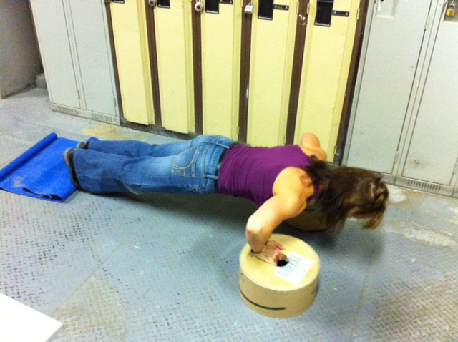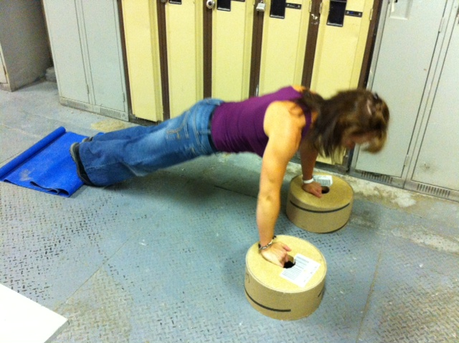

**Caution!!**

* If you are unsure of any of the exercises in the Mill Workout, see your onsite consultant for review!
* In hot conditions, avoid exertion
* Remember to continue breathing, exhaling on exertion (most difficult part of exercise).
* Exercise should never be painful! If the exercise causes pain (not just discomfort), stop immediately!

**Instructions:**

*Preparation:*

Lie prone on floor with hands slightly wider than shoulder width. Raise body off floor by extending arms with body straight.

*Execution:*

Keeping body straight, lower body to floor by bending arms. Push body up until arms are extended. Repeat.

*Rep Guidelines:*

**Muscle Group Targeted:**

*Chest, Arms*

Push Ups

Presents:

**The Mill Workout**