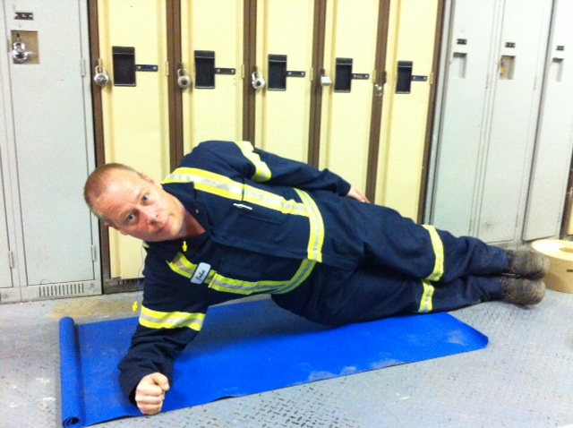

Side Plank

Presents:

**Caution!!**

* If you are unsure of any of the exercises in the Mill Workout, see your onsite consultant for review!
* In hot conditions, avoid exertion
* Remember to continue breathing, exhaling on exertion (most difficult part of exercise).
* Exercise should never be painful! If the exercise causes pain (not just discomfort), stop immediately!

**Instructions:**

*Preparation:*

Lie on side on mat. Place forearm on mat under shoulder perpendicular to body. Place upper leg directly on top of lower leg and straighten knees and hips.

*Execution:*

Raise body upward by straightening waist so body is rigid. Hold position. Repeat with opposite side.

*Rep Guidelines:*

**Muscle Group Targeted:**

*Abdominals*

**The Mill Workout**