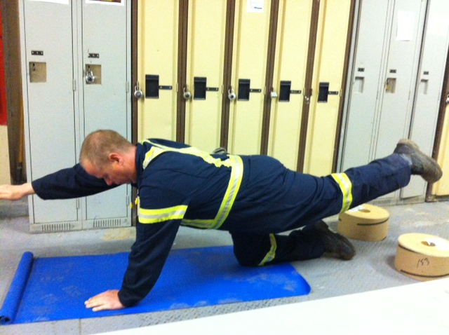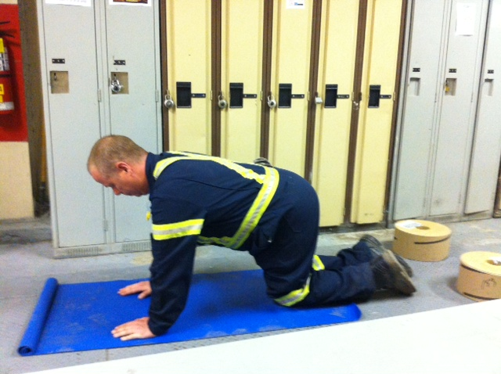

**Instructions:**

*Preparation:*

In hands and knees position on mat, position your knees under your hips and your wrists under your shoulders with fingers pointing forward. Engage your abdominal muscles and keep your spine neutral.

*Execution:*

In this exercise, you are attempting to move the opposite leg and arm simultaneously. Lift the leg off the floor until it is at or near parallel to the floor. Raise the opposite arm until it is at or near parallel to the floor. Your head should remain aligned with the spine throughout the movement. Lower yourself back to starting position and switch sides. Repeat.

*Rep Guidelines:*

**Muscle Group Targeted:**

*Abdominals, Hips, Back, Glutes*

**Caution!!**

* If you are unsure of any of the exercises in the Mill Workout, see your onsite consultant for review!
* In hot conditions, avoid exertion
* Remember to continue breathing, exhaling on exertion (most difficult part of exercise).
* Exercise should never be painful! If the exercise causes pain (not just discomfort), stop immediately!

Bird Dog

Presents:

**The Mill Workout**