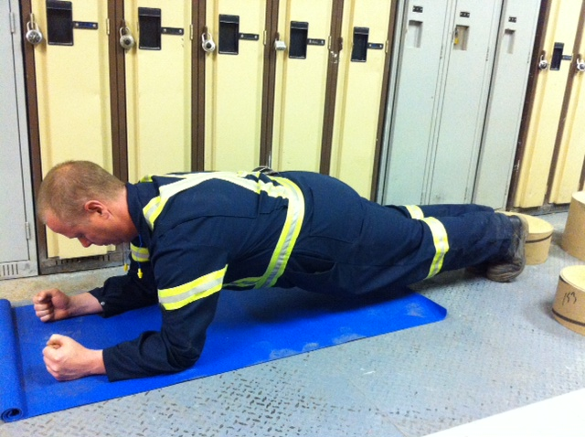

Presents:

**Caution!!**

* If you are unsure of any of the exercises in the Mill Workout, see your onsite consultant for review!
* In hot conditions, avoid exertion
* Remember to continue breathing, exhaling on exertion (most difficult part of exercise).
* Exercise should never be painful! If the exercise causes pain (not just discomfort), stop immediately!

**Instructions:**

*Preparation:*

Lie prone on mat. Place forearms on mat, elbows under shoulders. Place legs together with forefeet on floor.

*Execution:*

Raise body upward by straightening body in straight line. Hold position.

*Rep Guidelines:*

**Muscles Targeted:**

*Abdominals*

Plank

**The Mill Workout**