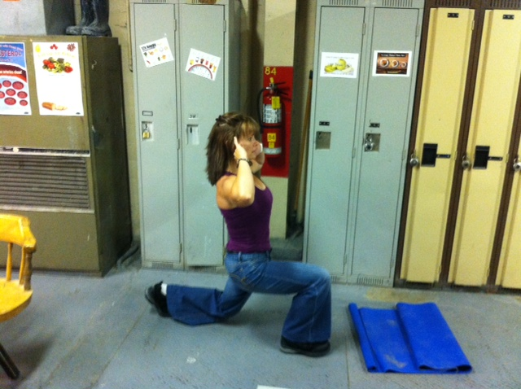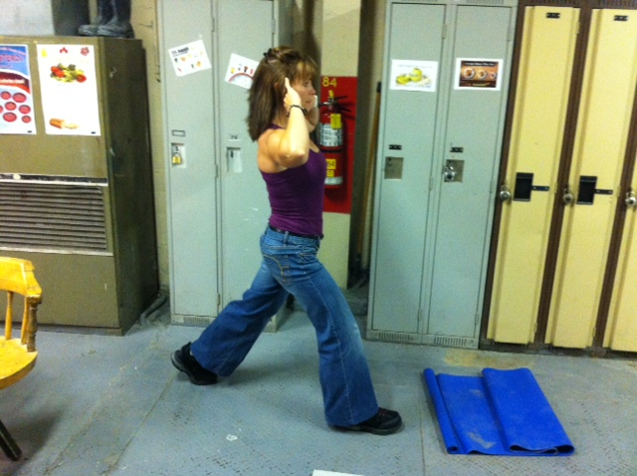

**Instructions:**

*Preparation:*

Stand with hands on hip, behind neck or at side of head with elbows out.

*Execution:*

Lunge forward with first leg. Land on heel then forefoot. Lower body by flexing knee and hip of front leg until knee of rear leg is almost in contact with floor. Return to original standing position by forcibly extending hip and knee of forward leg. Repeat by alternating lunge with opposite leg.

*Rep Guidelines:*

**Muscle Group Targeted:**

*Legs, Glutes*

Lunges

**Caution!!**

* If you are unsure of any of the exercises in the Mill Workout, see your onsite consultant for review!
* In hot conditions, avoid exertion
* Remember to continue breathing, exhaling on exertion (most difficult part of exercise).
* Exercise should never be painful! If the exercise causes pain (not just discomfort), stop immediately!

Presents:

**The Mill Workout**