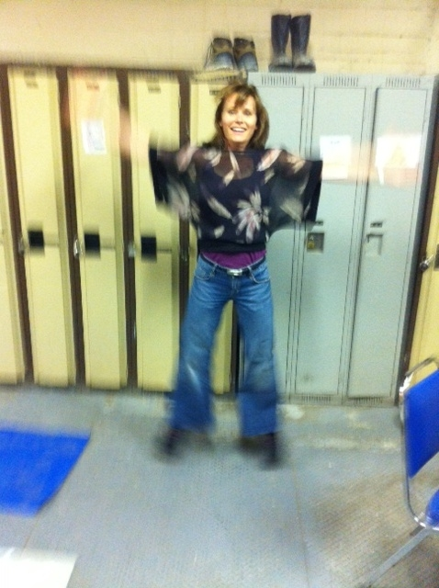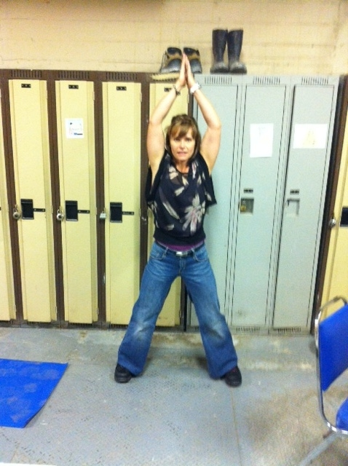

**Instructions:**

*Preparation:*

Stand with your feet together, knees slightly bent and arms to sides.

*Execution:*

Jump while raising arms and separating legs to sides. Land on forefoot with legs apart and arms overhead. Jump again while lowering arms and returning legs to midline. Land on forefoot with arms and legs in original position and repeat.

**Warning: Do **NOT** wear steel-toed footwear while performing this exercise!!

*Rep Guidelines:*

**Muscle Group Targeted:**

*Legs, Shoulders, Ankles, Hips*

**Caution!!**

* If you are unsure of any of the exercises in the Mill Workout, see your onsite consultant for review!
* In hot conditions, avoid exertion
* Remember to continue breathing, exhaling on exertion (most difficult part of exercise).
* Exercise should never be painful! If the exercise causes pain (not just discomfort), stop immediately!

Jumping Jacks

Presents:

**The Mill Workout**