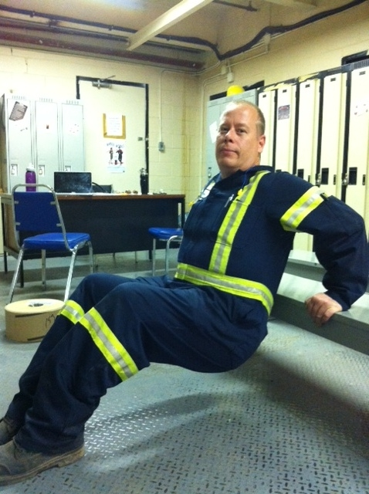

Tricep Dips

Presents:

**Caution!!**

* If you are unsure of any of the exercises in the Mill Workout, see your onsite consultant for review!
* In hot conditions, avoid exertion
* Remember to continue breathing, exhaling on exertion (most difficult part of exercise).
* Exercise should never be painful! If the exercise causes pain (not just discomfort), stop immediately!

**Instructions:**

*Preparation:*

Stand in front of chair or bench. Place hands on end of chair/bench with fingers off ends of chair/bench. Grip should be somewhat narrow. Position feet with legs bent and torso upright.

*Execution:*

Lower body by bending arms allowing elbows to point back. When slight stretch is felt in chest or shoulders, push body up until arms are straight. Repeat.

*Rep Guidelines:*

**Muscle Group Targeted:**

*Arms*

**The Mill Workout**