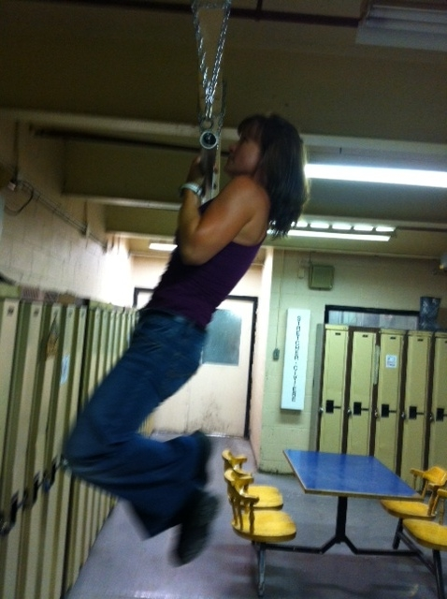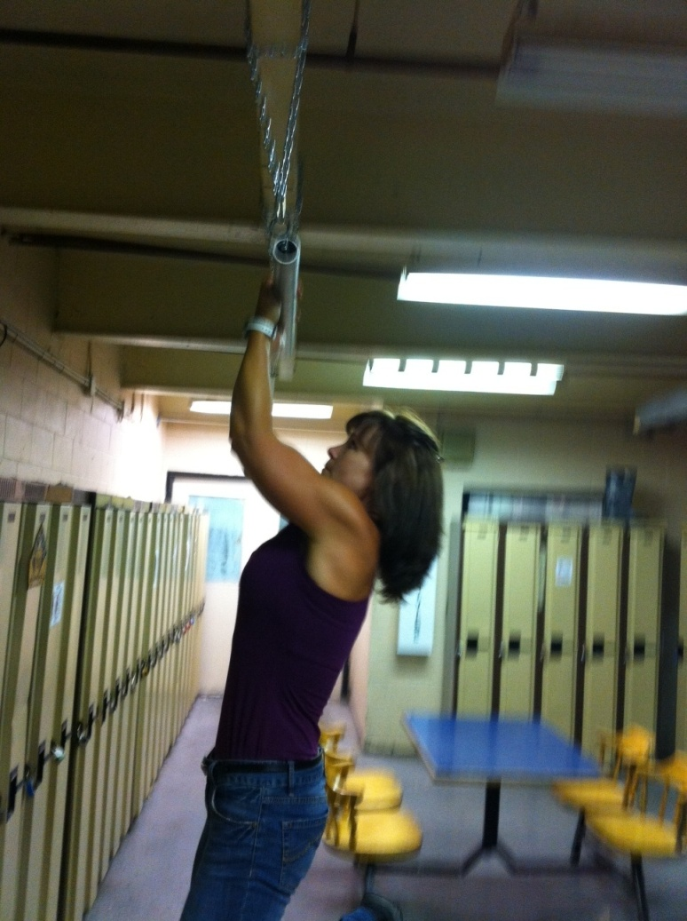

**Instructions:**

*Preparation:*

Step up and grasp bar with underhand shoulder width grip.

*Execution:*

Pull body up until elbows are to sides. Lower body until arms and shoulders are fully extended. Repeat.

*Rep Guidelines:*

**Muscles Worked:**

*Back, Arms*

Chin Ups

Presents:

**Caution!!**

* If you are unsure of any of the exercises in the Mill Workout, see your onsite consultant for review!
* In hot conditions, avoid exertion
* Remember to continue breathing, exhaling on exertion (most difficult part of exercise).
* Exercise should never be painful! If the exercise causes pain (not just discomfort), stop immediately!

**The Mill Workout**