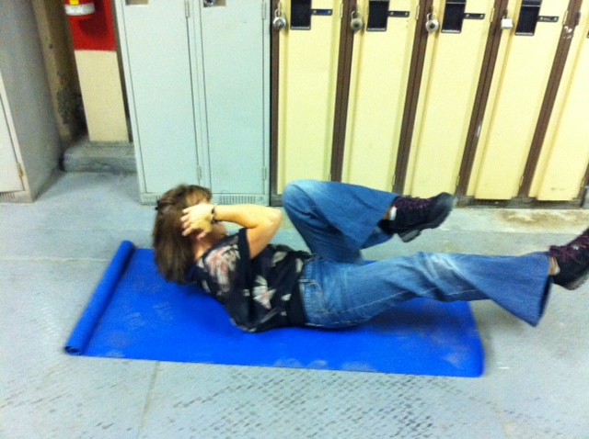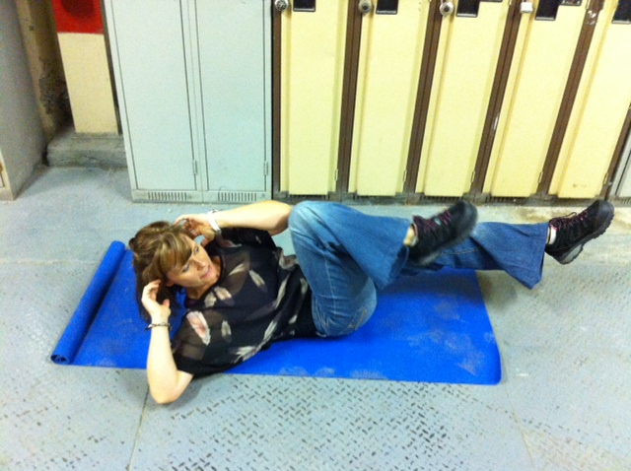

**Instructions:**

*Preparation:*

Lie flat on the floor with your lower back pressed to the ground and contract your core muscles.

*Execution:*

With your hands gently holding your head, lift your knees to about a 45 degree angle. Slowly, at first, go through a bicycle pedal motion. Alternately touching your elbows to the opposite knees as you twist back and forth. Breath evenly throughout the exercise.

*Rep Guidelines:*

**Muscle Group Targeted:**

*Abdominals, Hips*

**Caution!!**

* If you are unsure of any of the exercises in the Mill Workout, see your onsite consultant for review!
* In hot conditions, avoid exertion
* Remember to continue breathing, exhaling on exertion (most difficult part of exercise).
* Exercise should never be painful! If the exercise causes pain (not just discomfort), stop immediately!

Ab Cycle

Presents:

**The Mill Workout**