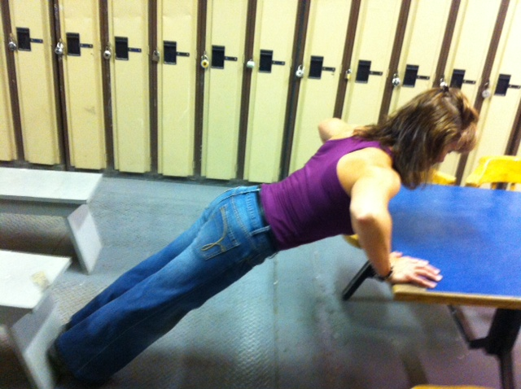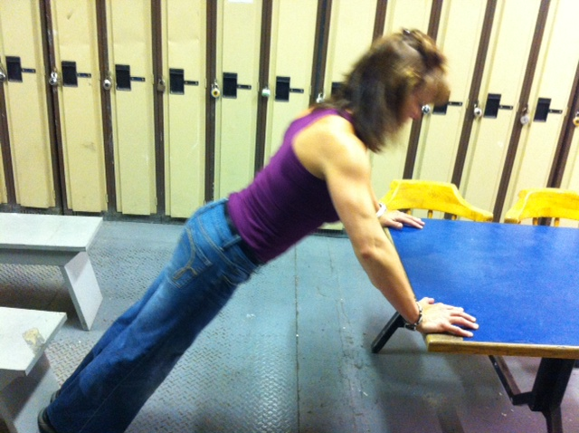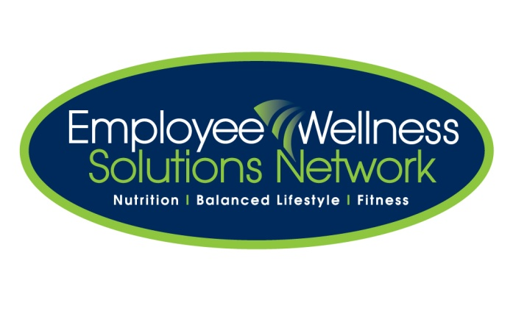

**Instructions:**

*Preparation:*

Stand facing sturdy elevated platform. Place hands on edge of platform, slightly wider than shoulder width. Position forefoot back from platform with arms and body straight. Arms should be perpendicular to body.

*Execution:*

Keeping body straight, lower chest to edge of platform by bending arms. Push body up until arms are extended. Repeat.

*Rep Guidelines:*

**Muscle Group Targeted:**

*Chest, Arms*

Elevated Push Ups

**Caution!!**

* If you are unsure of any of the exercises in the Mill Workout, see your onsite consultant for review!
* In hot conditions, avoid exertion
* Remember to continue breathing, exhaling on exertion (most difficult part of exercise).
* Exercise should never be painful! If the exercise causes pain (not just discomfort), stop immediately!

Presents:

**The Mill Workout**