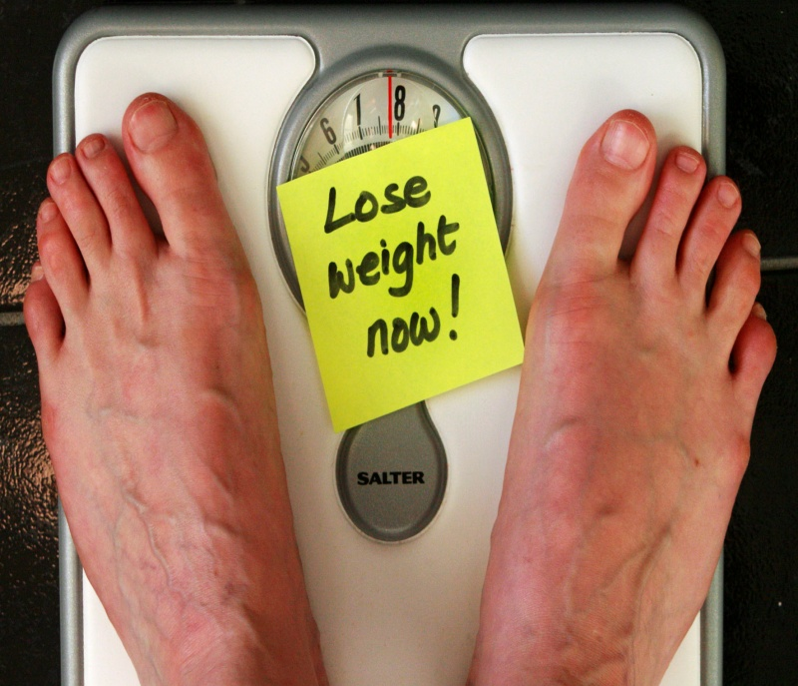

Contact your EWSNetwork Consultant TODAY to get started!

Name: Jane Doe

Email: [jdoe@ewsnetwork.com](mailto:jdoe@ewsnetwork.com)

**Step 1: Book a consultation with your EWSNetwork Consultant to decide on your challenge. They will assist you in creating a plan to achieve your goal, including breaking down your goal into manageable steps.**

**Step 2: Commit to the plan and follow it, including regular check-ins with your consultant to talk about your progress and make any modifications that may be needed as you get closer to your goal.**

**Step 3: Feel the immense personal satisfaction that comes with setting a goal and achieving it!**

**Do you have a personal goal that you would like to achieve? Would you like to quit smoking? Perhaps you want to run a 5K? Is that extra 25 pounds you have been carrying for the last 10 years starting to get to you?**

**EWSNetwork wants to help you achieve your lifestyle goals, whatever they may be!**

Choose Your Challenge!

Presents: