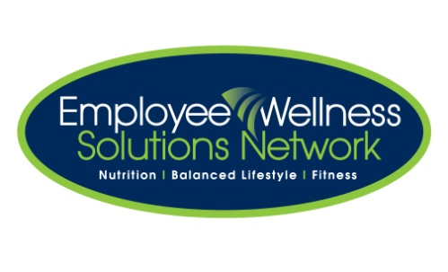

# Team Challenge

***Looking for some motivation to get started on your path to a healthy lifestyle?***

***Looking for a new challenge to mix up your current routine?***

***Looking to have some fun with co-workers while getting fit & healthy?***

***Get ready for a fun way to challenge yourself to reach your health & fitness goals while having some healthy competition with your co-workers!***

The Triple Threat Team Challenge is coming and will have you teaming up with two of your co-workers to create a team to participate in weekly challenges focusing on nutrition, cardiovascular and strength training exercises over a period of three weeks.

Complete challenges & earn points to be redeemed for ballots – at the end of three weeks, the team with the most ballots will be declared the champions of the Triple Threat Team Challenge!

**Team Sign-Up Deadline: Wednesday, September 4th**

**Competition Start Date: Monday, September 9th**

**Competition End Date: Friday, September 27th**

**Announcement of Winning Team: Wednesday, October 2nd**

So start gathering your team and feel free to email <Consultant> at <consultant@ewsnetwork.com> for further details.

Presents: