



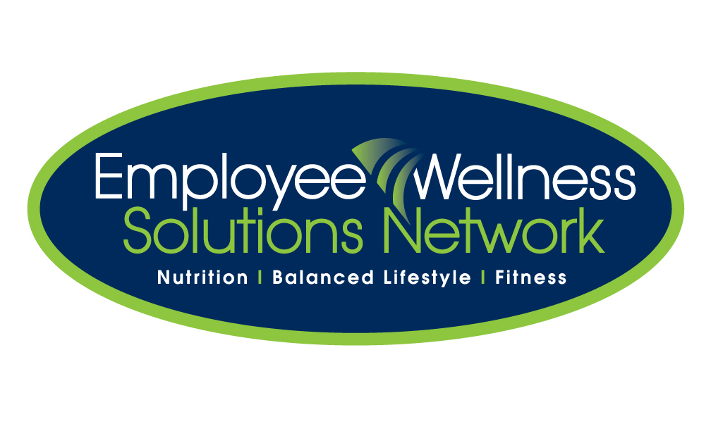



**Employee Wellness Program Proposal**

**May 2, 2013**

Employee Wellness Solutions Network (EWSNetwork) is an industry leader when it comes to corporate wellness. Since our inception in 2003 we have grown to service organizations in over 50 different cities. Currently, EWSNetwork services corporate clients across Canada and in two USA States with plans for continued growth.

EWSNetwork has the expertise and proven results-based system to service corporate clients ranging in size from less than 50 employees to over 1000. For each client, we maintain the highest quality of service and take pride in our ability to create individualized, successful programming for each organization.

Our clients come from a full spectrum of industries that include Financial Services, Automotive Manufacturing, Public Utility, Telecommunications, Office and Shipping, Insurance, Car Dealerships, Social Services, Warehouse, Law Firms, Banking, Education, Engineering, Construction and others.

We have a servicing network of over 30 wellness consultant professionals with many other strategic alliances in different communities that support our various programs.  Our unique system of recruiting, training and supporting the wellness professionals assures quality control.

EWSNetwork designs each customized corporate wellness program with three main components: ***Individual, Group and Awareness***. Our main focus is working with employees through lasting behavioral modification wellness initiatives. The unique and proprietary programs and systems engage employees from all levels of healthy behavioral change.

Strategically aligning the wellness program design to address the results of a health risk assessment [HRA], offering programs to support employee interests, and ensuring employee and management objectives are met, all contribute to a healthy return on investment.

**Why Employee Wellness Solutions Network?**

1. EWSNetwork brings a unique combination of individual, group and awareness programming geared to enhance each client’s overall participation rate and experience.
2. EWSNetwork has a team of program developers continuously developing various individual, group and awareness programs. These are designed to be client specific while also following the sought after trends in the industry. Each program created can be adapted to fit the needs of the client i.e. individual, awareness, group or even virtual.
3. EWSNetwork does not believe in “cookie-cutter” wellness programs. All of our programs are customized for each client based on a comprehensive analysis of an annual Health Risk Assessment and Metrics Analysis. We also collect information from our Interest Surveys and the Management and Wellness Committee Objectives Surveys.
4. EWSNetwork takes a multi-faceted approach to employee wellness. Not only do we focus on fitness and physical activity, EWSNetwork offers programs based around lifestyle, stress, sleep, nutrition, time management, along with many other areas of overall wellness.
5. EWSNetwork focuses on culture, morale and improved energy within the workplace through our various programs and has maintained very high participation and engagement rates at each of our clients.
6. EWSNetwork works closely with each client by creating an onsite Wellness Committee. Establishing the committee ensures that our programming is specifically designed to meet the requests and opinions of the staff.
7. EWSNetwork also works closely with various local wellness practitioners in each of our client’s cities. These strong relationships serve to benefit our clients as we have the ability to share their knowledge and expertise with our clients.
8. EWSNetwork specializes in recruiting, training and maintaining top quality health coaches with our proprietary system. We then pride ourselves on matching our health coaches with each client’s needs and requests.
9. EWSNetwork has built a one of a kind online tracking program that allows for real-time reporting on attendance, event participation, data trend reporting, unique program users and other data.
10. EWSNetwork’s unique online system has also been designed to allow all of our clients a password protected individual portal page. Here they can track personal wellness goals and data, access various resources, register for upcoming events and more.

**Seeing how wellness is more than just fitness, I present the following proposal as a comprehensive approach to workplace wellness.**

**Table of Contents**

**Page**

Proposal Agreement 4

Program Offerings 5

Program Cost 6

EWSNetwork Employee Wellness Program 7

One on One Schedule 7

Phone Consultations, Wellness Committee & Site Reps 8

Launching Program and Data Collection 9

Reporting and Marketing 10

What Clients Say… 11

Privacy Policy 12

Privacy Policy Agreement 13-14

Sample Year at a Glance 15-16

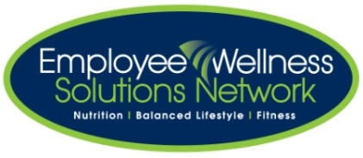

**502 Old Wonderland Rd.**

**London, On N6K 1L6**

**Tel: 519.860.0502**

**Fax: 1.**866.655.6675



**Moosehead**

**Employee Wellness Program Proposal**

**Objective:**

To initiate an employee wellness program for **Moosehead.**

Integrating wellness into the corporate culture will improve morale, energy, and overall stress management.

Employee Wellness Solution Network’s approach of addressing individual needs through proper assessment and program implementation leads to behavioural and lifestyle change.

Over time, the program may also help reduce absenteeism, drug and health costs, and assist in the retention and attraction of top employees.

**Proposed Start Date:**

August 1st, 2013

**Cost:**

(check preferred program)

* **$13.75 per month per employee** plus applicable taxes [details on page 4]
* **$11.65 per month per employee** plus applicable taxes [details on page 4]
* **$9.75 per month per employee** plus applicable taxes [details on page 4]

**Customer Acceptance:** I approve the proposal. Please formalize a contract in accordance to the order. Mailing address, payment plan, and other order instructions will be in the contract to follow.

Print Name & Position _________________________________________________________

Customer Signature ______________________________ Date _________________

*** Upon acceptance, a formal contract will be presented.

**Fax signed proposal to 1.866.655.6675**

**Program Offerings**

|  |  |
| --- | --- |
| **INITIATIVES** | **INCLUDED** |
| 1. On-site and/or Virtual Program Launch | X |
| 1. Annual, Semi-annual, and Quarterly Reports | X |
| 1. One-on-One Personal Wellness Consultations (in person, phone, skype) | X |
| 1. Awareness Material | X |
| 1. Packaged 4-8 week Awareness Programs * | X |
| 1. Team and Culture Building Programs * | X |
| 1. Group Exercise Classes * | X |
| 1. Lunch n’ Learns and Workshops * | X |
| 1. Virtual Programs | X |
| 1. Online Wellness Resource Centre | X |
| 1. EWS Network Monthly Newsletter and Monthly Challenge | X |
| 1. Annual Personal Wellness Profile | X |
| 1. Corporate Wellness Assessment Report [provided to management] | X |

* May vary depending on location, program design and size.

**Program Cost** [price and program are based on 360 employees]

(Plus applicable taxes)

***Optimal Comprehensive Wellness Program***

Cost - $13.75 per month per employee ($4,963.75 per month)

* Includes:
  + Above initiatives plus analysis, planning, scheduling, implementation and evaluation of an EWSNetwork wellness program.
  + Approximately 68 hours of one-on-one wellness consultations every month.

***Intermediate Comprehensive Wellness Program***

Cost - $11.65 per month per employee ($4,205.65 per month)

* Includes:
  + Above initiatives plus analysis, planning, scheduling, implementation and evaluation of an EWSNetwork wellness program.
  + Approximately 54 hours of one-on-one wellness consultations every month.

***Introductory Wellness Program***

Cost - $9.75 per month per employee ($3,519.75 per month)

* Includes:
  + Above initiatives plus analysis, planning, scheduling, implementation and evaluation of an EWSNetwork wellness program.
  + Approximately 40 hours of one-on-one wellness consultations every month.

**>>> Other options are available with further discussion.**

**Note: All additional professional costs including speakers, consultants, instructors, insurance and administration are covered in the above pricing.**

**EWSNetwork Comprehensive Employee Wellness Program**

Employee Wellness Solutions Network works diligently to provide unique program designs that target the needs and interests of any organization. Our focus is taking programming, information and initiatives directly to the employees, thereby maximizing participation. This unique approach ensures that your wellness program is reaching not only the people who are already interested in health, but also the people who need a wellness program the most.

Employee Wellness Solutions Network designs its wellness programs on four very important and necessary components for a successful wellness program. Combining all four of these components draws the largest employee engagement. Our approach addresses individual needs, establishes a healthy group culture, and enhances awareness across the workforce. Even for those with smaller satellite locations, our virtual programming ensures that there is truly something for everybody.

Employee Wellness Solutions Network is your expert for overall wellness strategies in the workplace. We work with your current benefits and offerings to maximize return.

**Wellness Program Design:**

In preparing this wellness program proposal and sample design, your company has provided EWSNetwork with the demographics, number of staff, and number of locations/sites. Our initial design is based on this information and around the Optimal Comprehensive Wellness Program option.

**One-on-One Consultation Schedule**

Individual one-on-one attention is a vital component to the success of a health and wellness program. The style of wellness consulting will include in person at some locations and phone and/or skype at others. This will allow the offering of consultations to everyone in the company and will also allow schedules to be adapted.

Below is a tentative monthly schedule of on-site wellness consultations based on location. A consistent on-site schedule at each of these locations will be designed. A confidential meeting room to hold the confidential consultations will be needed.

|  |  |  |  |  |
| --- | --- | --- | --- | --- |
|  | **Location** | **#s** | **Hours / Month** | **Shift Type** |
| 1 | Saint John | 248 | 43.00 | 2x 3hr shifts &  1x 4hr shift per month |
| 2 | Etobicoke | 38 | 8.00 | 2x 4hr shifts per month |
| 3 | TO Downtown | 14 | 6.00 | 3x 3hr shifts per month |
| 4 | Sales in ON | 20 | 11.00 | Phone Consultations  2x 4hr shifts &  1x 3hr shift  per month |
| 5 | USA | 14 |
| 6 | Dartmouth | 10 |
| 7 | Quebec, AB, BC | 9 |
| 8 | Moncton | 3 |
| 9 | Fredericton | 2 |
| 10 | Niagara Falls | 2 |
| 11 | Charlottetown | 1 |
|  | **Total Hours** | **361** | **99** |  |

*** If one of the above locations does not have the space for the consultations, it may be discussed to

conduct phone/Skype consultations instead.

**Phone and Skype Consultations [11 hours]:**

The 11 hours per month of consultations can be used with employees who are in locations with limited number of employees or with employees who are on the road during the normal consultation schedule or employees who find it difficult to make scheduled times. Wellness consultants will follow a fixed schedule. Some evening and morning times may be offered to accommodate various schedules.

Un-booked times will be allocated for “Consultant Check-ins”. Combining “Consultant Check-ins” and EWSNetwork “walkarounds/display stations” are very effective initiatives to keep participants on-task to modifying health behaviours.

Our customized on-line scheduling portal will make it easy for employees to book their appointment – be it in person, over the phone or skype.

**Wellness Committee:**

A wellness committee will be created and should be composed of 8-10 staff members. This group should consist of different ages, gender, geographical locations, and departments. We will be hosting a webinar every month to start [every other month to follow]. This group helps steer the program based on feedback and opinions.

**Site Wellness Representative:**

A site wellness representative will be named for each location. This person will be our main contact. Those representatives will aid in handing out, posting, setting up, etc. All details will be shared from a head office representative.

**Employee Wellness Solutions Network Systems**

**Launching the Program**

The launch of a wellness program is recommended to introduce the wellness program offerings to staff, to engage interest from the beginning, and to launch an initial wellness campaign.

Each organization is different and its launch is customized to fit the demographic, number of locations/satellite offices, on and off-site employees and other variables that make workplaces unique.

EWSNetwork works with you in strategizing the most effective launch possible.

**Launch Specifics:**

* A date[s] is chosen [depending on organization size and make-up].
* The launch is marketed with posters, emails, flyers, paystub drops, announcements, memos, intranet and any other mode that is applicable.
* An EWSNetwork representative presents the various components of the wellness program and introduces the certified wellness consultants who will be working with your organization.
* Employees have an opportunity to schedule their first one-on-one consultation at the launch.
* Employees have an opportunity to sign up for the wellness committee.
* The Health Risk Assessment [Personal Wellness Profile] is launched.
* The wellness consultations begin shortly after the launch.

**Data Collection for Optimal Program Design:**

Over the course of the first 30-45 days of a program Employee Wellness Solutions Network is diligent in gathering as much information as possible to design and implement targeted group and awareness programs. *[A sample Year-At-A-Glance can be seen on pages 15-16]*

In this initial period we gather the following information to ensure the wellness program is designed to meet the needs, interests and challenges within your organization.

1. Client Data Collection – An EWSNetwork representative gathers client-specific information once the wellness program has been approved. Data includes organization make-up, contact person[s] at the organization, launch specifics, baseline measurements for absenteeism, health claims costs, and other procedures, offerings, and logistics.
2. Corporate Trend Report – Following the HRA campaign, a corporate trend report is analyzed and health risks are profiled for the organization. Management receives a detailed report and top health action opportunities are shared with the wellness committee for strategic design of the program.
3. Individual Feedback – A short interest survey may be circulated to gather staff interests.
4. Wellness Consultations – Common trends are recognized by the wellness consultants.
5. Wellness Committee – A meeting is scheduled shortly after the launch to acquire clearer understanding of scheduling, departments, shifts, levels of the organization, etc. This knowledge will help with planning and marketing of future programs.
6. Objectives Surveys - Both the wellness committee and management will be asked to complete a Wellness Program Objectives Survey to ensure the program design and execution is in line with expectations.

**Reporting**

Annual Health Risk Assessment – The annual health risk assessment [Personal Wellness Profile] corporate report provides a look at common health risk trends. To see a sample of a corporate report, please go to [Sample Report](http://news.ewsnetwork.com/HRASampleReport/flipviewerxpress.html) [<http://news.ewsnetwork.com/HRASampleReport/flipviewerxpress.html>]

Semi-Annual Progression Report – Progression reports are presented every 6 months outlining initiatives, participation rates, and current and future program design strategies.

Snap-Shot Report – Snap-shot reports are provided every quarter. Various measurements and updates are included.

**Marketing**

Marketing and awareness on upcoming programs is crucial for success. EWSNetwork uses all available resources within your organization to maximize programming efforts. Common practices include:

1. Wellness committee and site representatives – The committee is made up from a cross-section of the organization. All/any departments, levels of management, front-line staff are encouraged to participate. Participants are encouraged to be ambassadors of the wellness program. Some major roles include helping with marketing efforts, helping with implementation of various initiatives and gathering feedback from peers.
2. Flyers, posters, email campaigns – These and other modalities specific to the organization help promote upcoming programs at the various locations and departments. Ensuring that each initiative has ample marketing is key to a successful program.
3. Ongoing presence – EWSNetwork representation at various staff meetings, management events, and departmental meetings has been shown to help with promotion of the wellness program.
4. Wellness consultants - The wellness consultants help with overall promotion of the program via group events, wellness walkarounds [where applicable], health promotions, and other opportunities.
5. Awareness programs – With the customization of the EWSNetwork wellness program, various awareness campaigns are implemented. These, in of themselves, work to market the wellness program. Examples include kiosks, e-campaigns, wellness walkarounds [where applicable], promotions, etc.

**What do some of our clients say…**

*Working with EWSNetwork is about more than just ensuring your staff have access to knowledge and personalized supports that encourage them to live more healthy lives – it’s also about team building and showing that you care as an employer.  In working with EWSNetwork I have been impressed at the time they have taken to understand our organization and our staff, and to customize an approach that truly met the needs of our employees in various locations.  The result of this thoughtful planning is that over 70% of our employees are engaged in the program, health benefit costs have been kept stable, and most importantly, our staff know each other better.*

* **Peter Frampton, Executive Director, Learning Enrichment Foundation**

*Taking a proactive approach to wellness, EWSNetwork is assisting Libro staff to take charge and work towards a healthy lifestyle.  Partnering with EWSNetwork in January of 2013, we have a participation rate of over 80% of our company and the excitement of this program is continuing to spread.*

*One-on-one wellness consultations allows staff the opportunity to speak on topics they choose, in a safe and confidential environment.  The wellness consultants have done a great job in providing staff with creditable information and tools to move forward with their wellness goals.*

*The proactive approach to healthy living is what Garth, Meaghan and the great team at EWSNetwork promote each and every day to over 250 staff at Libro!*

* **Theresa Mikula, VP Human Resources, Libro Financial Group**

*Farnell Packaging has recently embarked on a wonderful new partnership with the team at EWSNetwork. They are caring, knowledgeable and down-to-earth professionals who are bringing a wealth of valuable information and on-site resources into our workplace. We are already receiving very positive feedback from staff who are benefiting from the personal wellness consultations and feeling they have access to the support and information that will lead them towards success in their wellness goals. We have a strong belief that this investment in our staff will have excellent short-term and long-term benefits.*

* **Judy Farnell, President, Farnell Packaging**

*We have had a partnership with Employee Wellness Solutions Network (EWSNetwork) for over 5 years.  They have been instrumental in establishing our employee wellness program and in facilitating our in-house employee committee.  The tools available to our staff through their online web site as well as through personal one-to-one individualized consulting have been well received by our staff and assisted them with reaching their personal wellness goals.  Their creative and professional team provides many ways of educating our staff on wellness and healthy living options.  Our employee participation rate is good and changes for the varied exercise programs.  EWSNetwork have implemented departmental fitness challenges that have benefited our staff morale as well as provided a healthy work environment.  Our staff look forward to every event, whatever it may be.*

* **Grant Wren, Human Resources Manager, Amway Global Canada**

**Privacy**

EWSNetwork takes privacy seriously. We take every measure to ensure privacy and confidence of participants. Below are some of the ways.

1. EWSNetwork Email System - At the launch, we will share various email addresses that are directed to members of our team. A company-specific address will also be customized and would ensure all feedback, comments and suggestions are shared with us, directly. An example of a secure address might be [moosehead@ewsnetwork.com](mailto:moosehead@ewsnetwork.com) for participants’ use.
2. Health Risk Assessment – The HRA identifies the client’s privacy. The information is secured. Below is a section of the HRA waiver that identifies such privacy and confidentiality.
   * *Use of Personal Information.  Upon your consent to this end user notice, your answers to the questionnaire may be disclosed to Employee Wellness Solutions Network Inc., the licensee of the Wellsource® system. However, your company or organization will not have access to your personal information unless you provide a separate consent in writing authorizing your personal information to be released.  
     Wellsource has taken steps to contractually require its system licensees to fully comply with laws and regulations on the use of personal information; however, Wellsource does not ultimately control the privacy and security practices of licensees.  If you consent to be bound by this end user notice, information about you may be shared with Employee Wellness Solutions Network Inc. in two forms: (1) aggregate data (your data combined with those of other participants which does not personally identify you), and (2) personally identifiable data (data specific to and identifiable to you).  However, only aggregate data (your data combined with those of other participants which does not personally identify you), will be shared with your employer.  
     Protecting the confidentiality of participants and their data is of the utmost concern to Wellsource, which takes extensive measures to ensure their staff adheres to all applicable privacy laws.  Unless specifically requested by the licensee of the Wellsource® system, Wellsource staff does not access the personal health information you submit through this online system.  
     You may request that your program administrator delete your Personal Wellness Profile at any time and any data that is personally identifiable to you will be completely deleted; however, we cannot guarantee that your information in aggregate (group) form will be completely removed from the Wellsource® system.*
3. EWSNetwork Privacy Policy - Employee Wellness Solutions Network recognizes that its clients value the privacy of their personal information. Our commitment to protecting the privacy and confidentiality of your personal information is addressed in our privacy policy. Our policy complies with the requirements of the Personal Information Protection and Electronic Documents Act. *[See EWSNetwork Privacy Policy on page 13&14]*

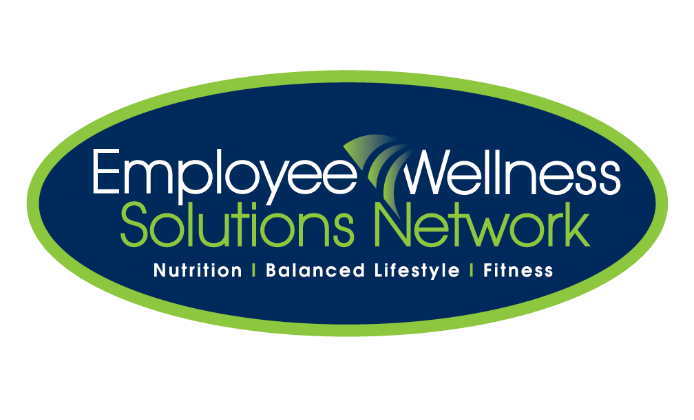

**Employee Wellness Solutions Network™**

**Privacy Policy**

**Our Policy Respecting Your Privacy and the Protection of Personal Information**

Purpose

Employee Wellness Solutions Network recognizes that its clients value the privacy of their personal information. Our commitment to protecting the privacy and confidentiality of your personal information is addressed in this privacy policy. Our policy complies with the requirements of the Personal Information Protection and Electronic Documents Act.

Accountability

All personal information held or collected by Employee Wellness Solutions Network is protected under the Privacy Act. This means that at any point of collection you will be asked for consent to collect your information, and you will be informed of the purpose for which it is being collected. You will also be advised how you can exercise your right of access to that information.

Employee Wellness Solutions Network has appointed a Privacy Officer to ensure our staff’s compliance with this Privacy Policy.

Personal Information

Employee Wellness Solutions Network is committed to helping each wellness program member achieve his or her personal wellness goals safely and effectively. Employee Wellness Solutions Network collects personal information from each member during the registration process to ensure member safety.

Personal information about our wellness program members is collected during the in-person consultations, online assessments, fitness assessment data collection form, PAR-Q (Physical Activity Readiness Questionnaire), medical release form, and the Personal Wellness Profile [PWP]. Members provide this information voluntarily as a condition of participating in the wellness program. All such information is confidential and Employee Wellness Solutions Network licensees, consultants and staff are instructed that this information will not be divulged to anyone. Personal information collected during in-person consultations, online assessments, fitness assessment data collection form, medical release form, and PAR-Q are accessible only by the wellness consultants.

Individual’s personal information, consultation notes, PAR-Q’s and other forms are stored in the members’ files in a locked filing cabinet. This cabinet is locked at all times, except when opened by the wellness consultant. The cabinet is re-locked after each access.

Employee Wellness Solutions Network also collects personal information including name, email address, work and home phone numbers to identify you as an individual and to ensure efficient follow-up in the case of an emergency. This information is stored in a locked filing cabinet in each client’s personal file.

We will not use or disclose your personal information for any purposes other than those for which it was collected, except with your consent or as required.

Consent

Your knowledge and consent is required for the collection and use of your personal information. When you become a wellness program member you consent to the use of your personal information for the purposes listed above. You may at any time refuse or withdraw your consent, however, you may not be able to participate in the wellness program.

Employee Wellness Solutions Network may also collect information regarding the frequency of your visits to consultations and participation in other programs to assist in justifying the value of the program. Employee Wellness Solutions Network may also use this information to follow-up on clients who have stopped using the program to find out why and provide support as requested.

Accuracy

Employee Wellness Solutions Network will take steps to help ensure that your personal information remains as accurate, complete and up-to-date as is reasonably necessary for the intended purposes. Annually Employee Wellness Solutions Network will request that each wellness program client completes a PAR-Q form and Personal Wellness Profile [PWP].

Safeguards

Each of our licensees, consultants and staff is responsible for storing your personal information to which they have access in a secure place. We keep our licensees, consultants and staff informed about our policies and procedures for protecting personal information.

Changes to Our Privacy Policy

From time to time, it may be necessary for Employee Wellness Solutions Network to change this Policy. We will notify all our members by email to changes in our policy.

Inquiries

All inquiries or complaints regarding our privacy policy should be directed in writing by mail, fax or email to Employee Wellness Solutions Network’s Privacy Officer. All inquiries will be responded to within thirty (30) days from the date at which our Privacy Officer has received the inquiry.

**Privacy Officer:**

Garth Jansen

502 Old Wonderland Rd. London, ON N6K 1L6

p. 519.860.0502

f. 1.866.655.6675

e. [garth@EWSNetwork.com](mailto:garth@EWSNetwork.com)

|  |  |  |  |  |  |  |  |  |  |  |  |  |  |
| --- | --- | --- | --- | --- | --- | --- | --- | --- | --- | --- | --- | --- | --- |
| **January – June 2013** | | | | | | | | | | | | | |
| **Initiative** | **January** | | | | **February** | | | **March** | | **April** | **May** | | **June** |
| **Consultations** | One-on-One Consultations/Phone/Skype Schedule (ongoing) | | | | | | | | | | | | |
| **Individual** | Online Profile and Wellness Tracking | | | | | | | | | | | | |
| **Kiosk Posters** |  | | | | Blood Pressure Kiosk | | |  | | Diabetes Kiosk |  | |  |
| **Webinar** |  | | | | Healthy Home (evening) | | |  | | Healthy Home (evening) |  | | Healthy Home (evening) |
| **Lunch n' Learns** |  | Healthy Hearts | | | |  | | Nutrition and Energy | |  | Healthy Weights Workshop (4weeks) | |  |
| **Posters** | BP and Cholesterol | | | | | | | Healthy Snacking and Energy | | | Exercise and Movement | | |
| **Newsletter** | Ongoing Monthly Newsletters | | | | | | | | | | | | |
| **Wellness Challenge** |  | Eat to Lower Chol. and BP | | | | |  | Eat More Fruits & Vegetables | |  | Eat Breakfast Daily | |  |
| **Walk Around or Station Awareness** |  | | | Rooibos Tea | | |  | Serving Size /Portion Control | |  | Lemon in Water | |  |
| **Challenges** | Healthy Employee and Office of the Quarter Award | | | | | | | | | | | | |
|  | | | |  | | | Nutrition Challenge | | |  | |  |
| **Group Exercise Classes** |  | | | | Yoga Sampler | | | | |  |  | |  |
| **Email or Paystub Campaign** |  | | Healthy Hearts  (every other week) | | | | |  | Healthy Recipe  (every other week) | |  | Walking Works  (every other week) | |
| **Corporate Reporting** |  | | | |  | | |  | | Snapshot Report |  | | Progression Report |

**Sample “Year-in-a-Glance”**

|  |  |  |  |  |  |  |  |  |  |  |
| --- | --- | --- | --- | --- | --- | --- | --- | --- | --- | --- |
| **July – December 2013** | | | | | | | | | | |
| **Initiative** | **July** | **August** | **September** | | | **October** | **November** | | | **December** |
| **Consultations** | One-on-One Consultations/Phone/Skype Schedule (ongoing) | | | | | | | | | |
| **Individual** | Online Profile and Wellness Tracking | | | | | | | | Personal Wellness Profile | |
| **Kiosk Posters** |  |  |  | Beat the Bug | | | | |  |  |
| **Webinar** |  | Healthy Home (evening) |  | | | Healthy Home (evening) |  | | | Healthy Home (evening) |
| **Lunch n' Learns** |  |  | It’s in You to MOVE | | |  | Maintain Don’t Gain | | |  |
| **Posters** | Small Steps to Fit | | Walking Works | | | | Maintain Don’t Gain | | | |
| **Newsletter** | Ongoing Monthly Newsletters | | | | | | | | | |
| **Wellness Challenge** | Exercise 30-60 Minutes Daily |  | Walk 6000-10000 Steps Daily | | |  | Stay Fit During the Holidays | | |  |
| **Walk Around or Station Awareness** | Dark Chocolate |  | Almond Serving | | |  |  | | |  |
| **Challenges** | Healthy Employee and Office of the Quarter Award (ongoing) | | | | | | | | | |
|  |  | Track Your Distance Challenge | | | |  | | |  |
| **Group Exercise Classes** |  |  | Walking Group and Routes | | | |  | | |  |
| **Email or Paystub Campaign** |  |  |  | | Tips to Beat the Bug (every other week) | | |  | Maintain Don’t Gain  (every other week) | |
| **Corporate Reporting** |  |  | Snapshot Report | | |  | HRA Reporting | | | Annual HRA Report |