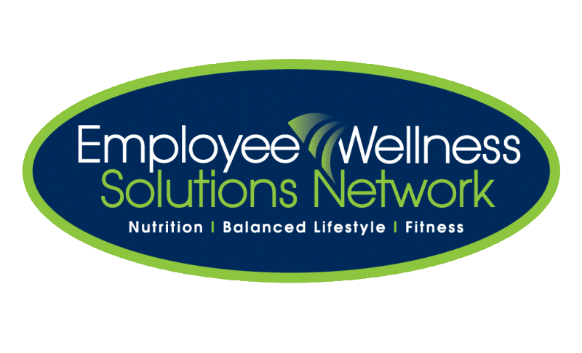

Topics to be discussed will include:

* GMOs and pesticides
* The benefits of eating organic & raw
* How to eat organic on a budget
* Great ways to choose local over imported foods

.....and more!

TO REGISTER for “Organic, Local & Raw” Lunch and Learn:

See registration link in email or email us at <insert email address>

Bring your lunch and join us for some “food for thought”!

“Organic, Local & Raw”

Date: <Insert Date>

Time: <Insert Time>

Location: <Insert Location>

Presents: