**Employee Wellness Solutions Network**

**Personal Wellness Profile [Health Questionnaire]**

**Log-in Website**

[**www.EWSNetwork.com/libro**](http://www.EWSNetwork.com/libro)

**Step #1**

Click **NEW USER REGISTRATION**

(Find in the top left hand corner.)

**Step #2**

Create and Enter Username, password

and fill in other information

(Important: Please remember this for next year!)

**Step #3**

Fill out questions on each page. Click NEXT….

**Step #4**



Print Report



* Complete your health questionnaire and you could WIN **\*\*$500 OR *$100 Sport Chek Gift Card**!
* Questionnaire takes only 10 minutes!
* Get a personalized report!

*\*\*All EWSNetwork clients are eligible.*

*\*only Libro participants eligible.*



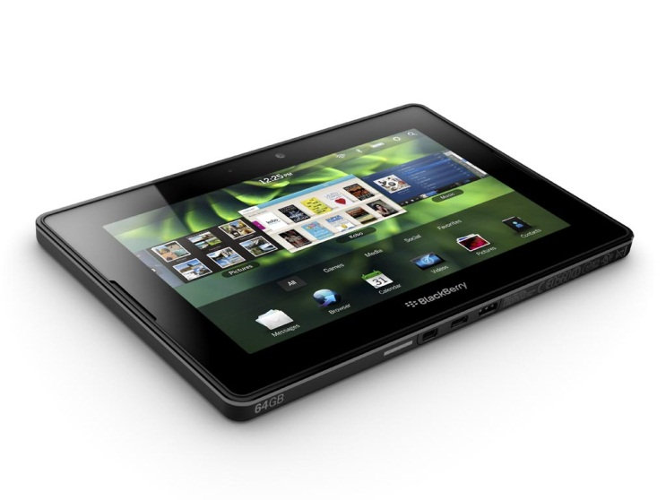

Connect with one of the awesome EWSNetwork Wellness Consultants

to discuss your results!