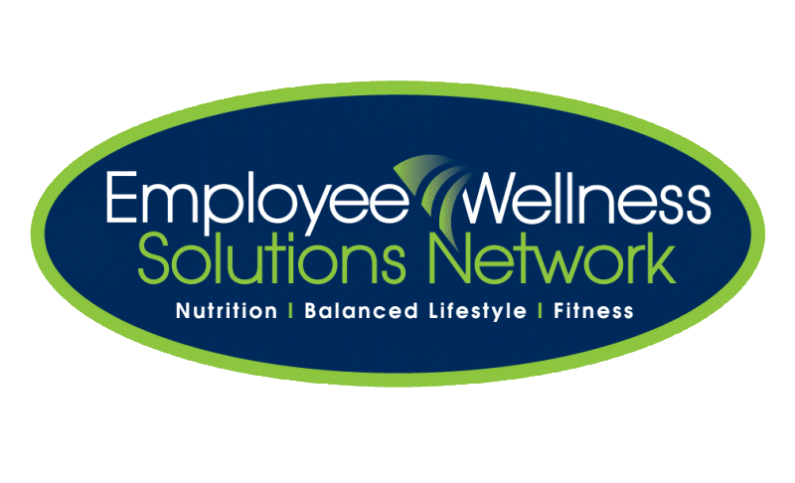

Fit & Lean in 2014

Presents

Are you looking to improve your health & get fit in 2014 but not sure how to get started?

Register for this 8-week program and you will:

* Learn the fundamentals of nutrition & fitness
* Get tips on healthy meal planning
* Receive support from co-workers and your EWSNetwork health coach
* Receive worksheets, tip sheets, charts and tracking tools to use in class and at home
* Have access to great healthy recipe ideas
* Get advice on eating healthy on a budget
* Be inspired & learn how to stay motivated
* Learn how to set and achieve goals
* Have access to one-on-one advice from your EWSNetwork health coach
* Receive encouragement when you stumble and acknowledgment when you achieve a goal



TO REGISTER for the “Fit & Lean in 2014” program:

See registration link in email or email us at <insert email address>

Start Date:

Time and Location:

Presented By:

**…and much more!!**