

**Nuggets of Nutrition**

Learning how to read and interpret the nutritional information on a food label is imperative to living a healthy lifestyle. Here are two labels to two different bread options. Look them over and then answer the below questions.

Bread Option #1

Bread Option #2

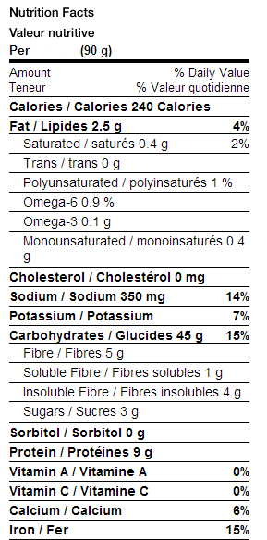

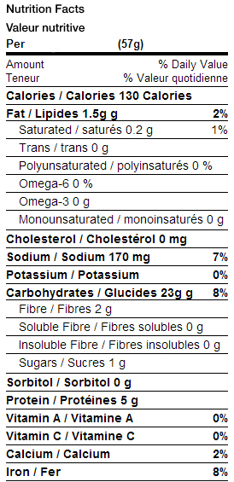****

**Questions:**

1. Which bread is higher in calories?

2. Which bread is lower in fat?

3. Which bread contains more sugar?

4. Which bread is higher in protein?

5. Which bread is higher in calcium?

6. Which bread do you feel would be a healthier choice and why?

**A. McDonald’s Fruit & Yogurt Parfait**

**B. Cooked Long-Grain White Rice**

**C. Boneless, Skinless Chicken Breast (Roasted)**

**D. 2% Cottage Cheese**

**E. Medium Apple with skin**

**F. Raw Kale**

**Match the food label to the food item!**

**Label #3 = ____**

**Label #2 = ____**

**Label #1 = ____**

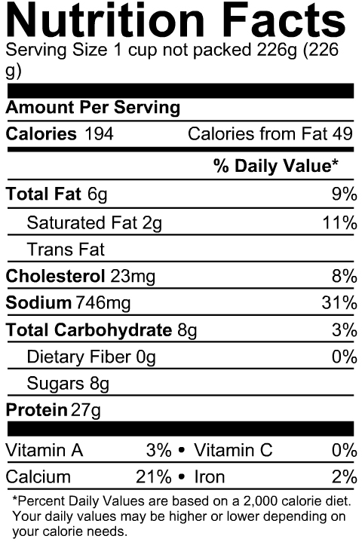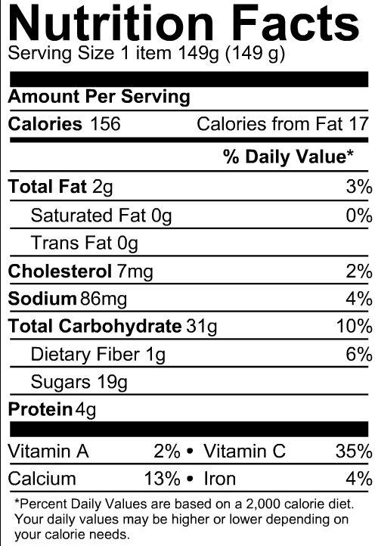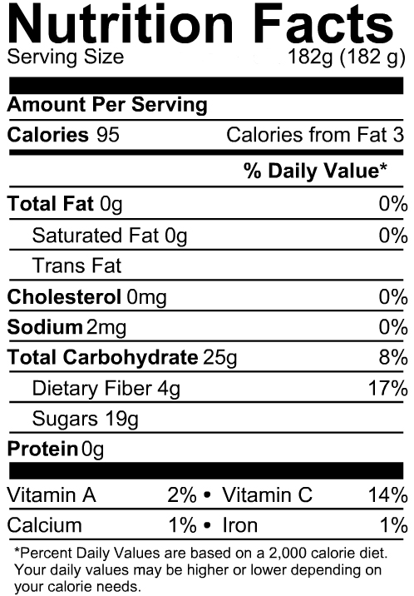

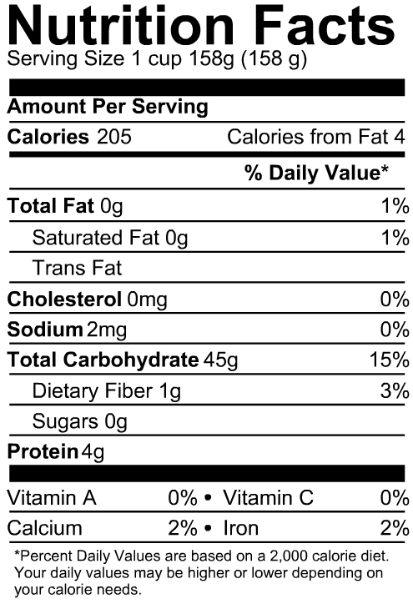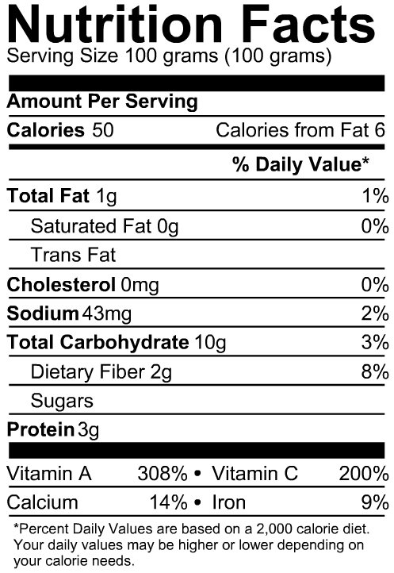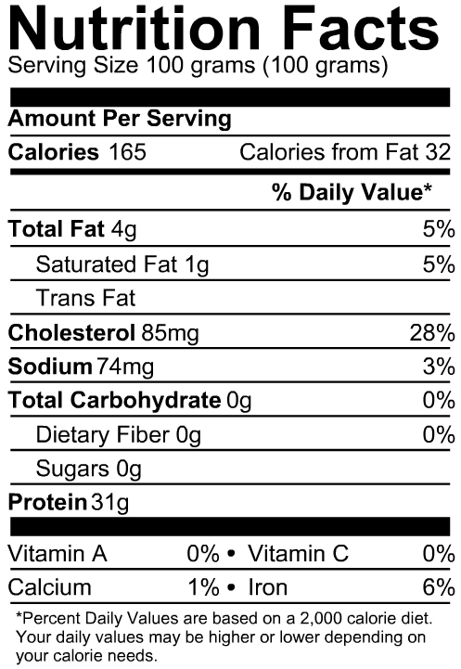

*Source:* [*www.nutritiondata.self.com*](http://www.nutritiondata.self.com)

**Label #6 = ____**

**Label #5 = ____**

**Label #4 = ____**