

**Nuggets of Nutrition**

Learning how to read and interpret the nutritional information on a food label is imperative to living a healthy lifestyle. Here are two labels to two different yogurt options. Look them over and then answer the below questions.

Yogurt Option #2

Yogurt Option #1

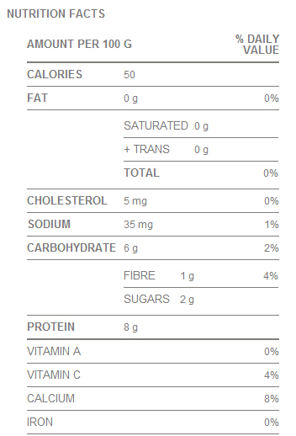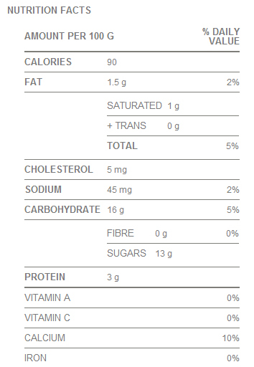****

**Questions:**

1. Which yogurt is higher in calories?

2. Which yogurt is lower in fat?

3. Which yogurt contains more sugar?

4. Which yogurt is higher in protein?

5. Which yogurt is higher in calcium?

6. Which yogurt do you feel would be a healthier choice and why?

**Match the food label to the food item!**

**A. Domino’s Large Pepperoni Pizza (1 slice)**

**B. Cooked Quinoa**

**C. Kellogg’s All-Bran with Extra Fibre**

**D. Lean Cuisine Macaroni & Beef w/Tomato Sauce**

**E. Hard Boiled Egg**

**F. Condensed Tomato Soup (Reduced Sodium)**

**Label #3 = ____**

**Label #2 = ____**

**Label #1 = ____**

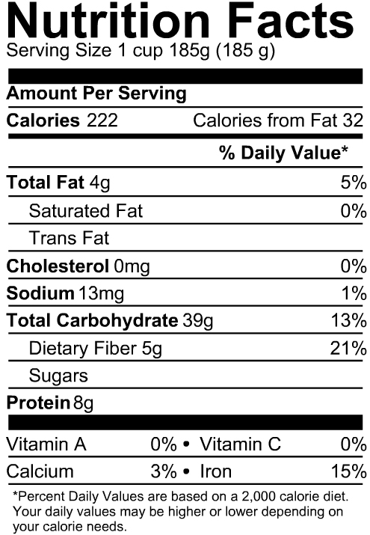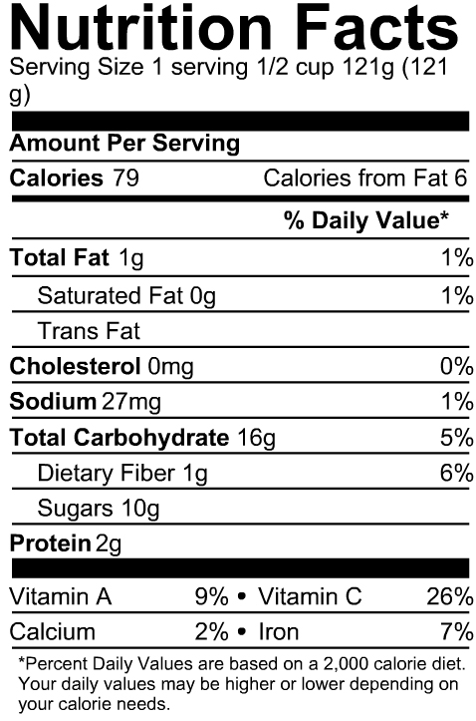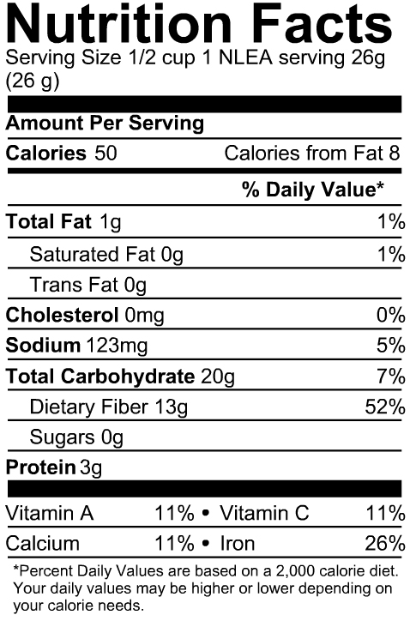

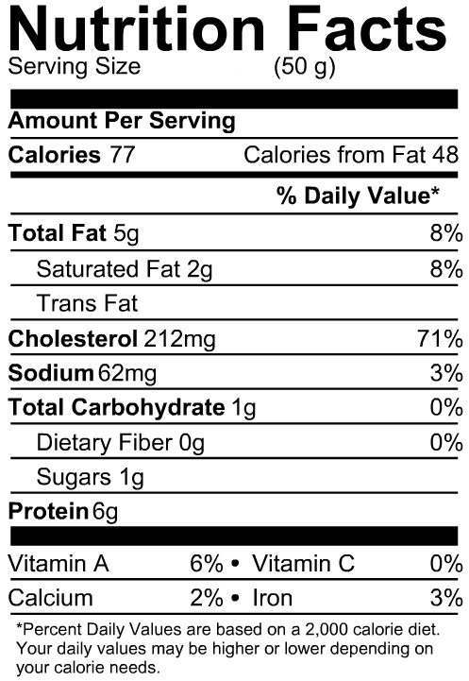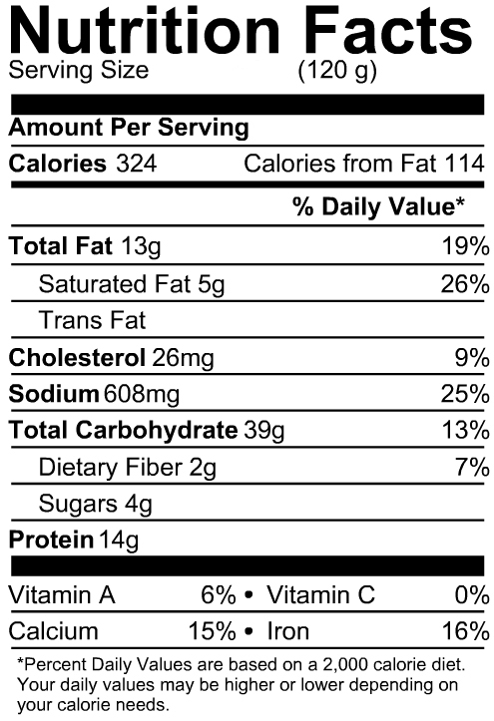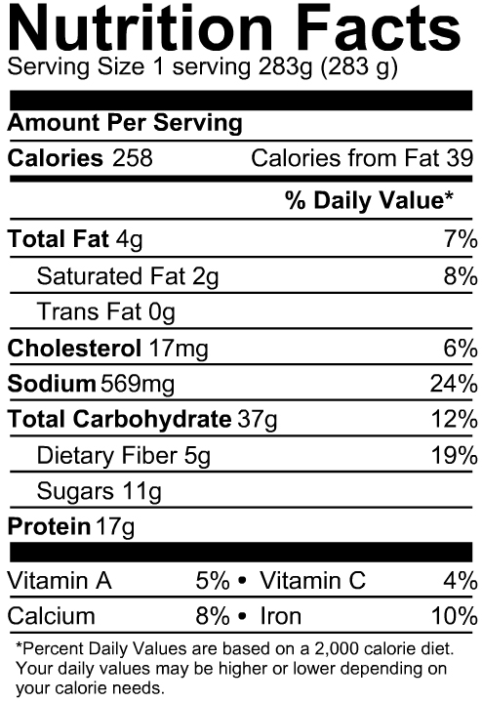

*Source:* [*www.nutritiondata.self.com*](http://www.nutritiondata.self.com)

**Label #6 = ____**

**Label #5 = ____**

**Label #4 = ____**