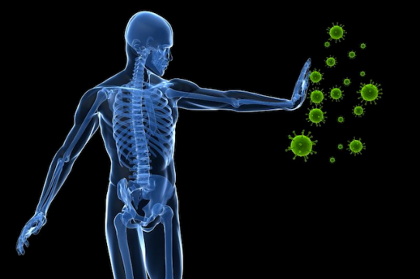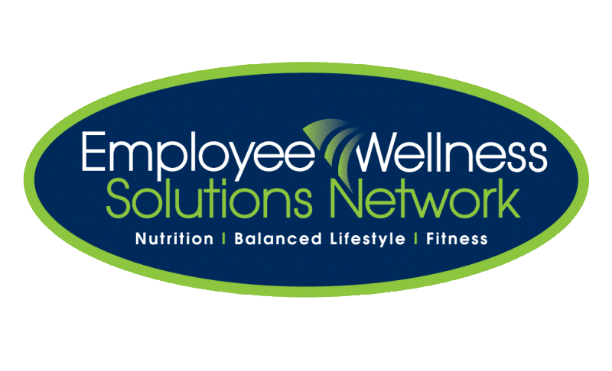

As we are rapidly approaching cold & flu season, it’s a great time to take some steps to strengthen your immune system! Join your co-workers and complete immune-boosting tasks to see who will be the ultimate “survivor”! See your email or EWSNetwork Consultant for details!

Dates: <insert dates>

**Immunity Challenge**

Encourages you to Join Our