**

**EWSNetwork Portal Quick Reference Video**

*Tips to navigating through the User Dashboard*

For more detailed instructions on the User Dashboard, you can access the

Portal Training Video via the link below.

Video start times for each section are noted below.

[**http://youtu.be/8kTNO_x8RM8**](http://youtu.be/8kTNO_x8RM8)

**Signing into the Portal**

**(Start Time - 0.30)**

[www.ewsnetwork.com](http://www.ewsnetwork.com)

Click on the “Member Login” button - half way down, right hand side of the page.

This will take you to the sign-in page below.

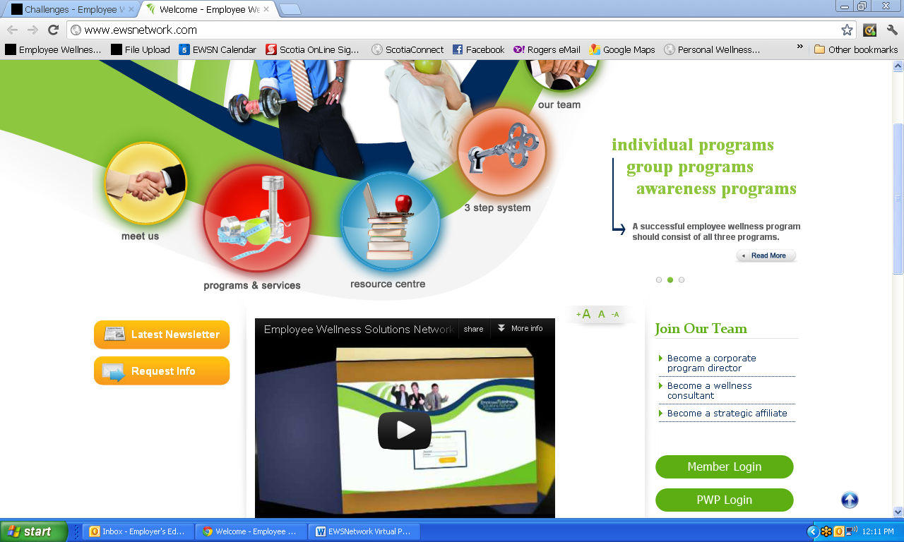

**Member Login Page**

**Your user name** = your email address or first name last name - all one word lower-case. (ie. johnsmith)

**Password** = Temporary password provided by EWSNetwork (which can be changed after initial sign-in)

**Click Login**

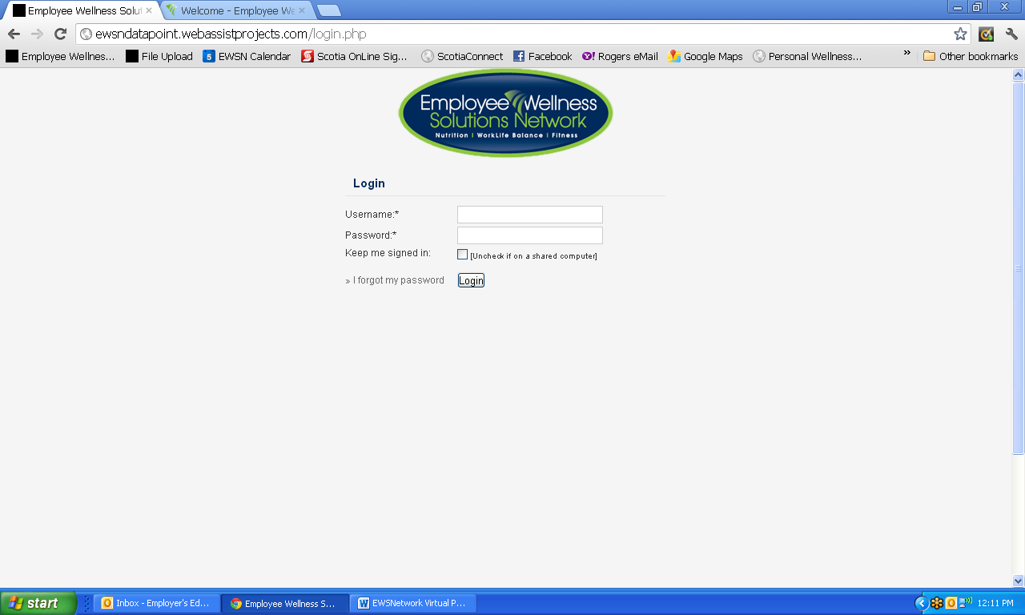

**Change Password Button**

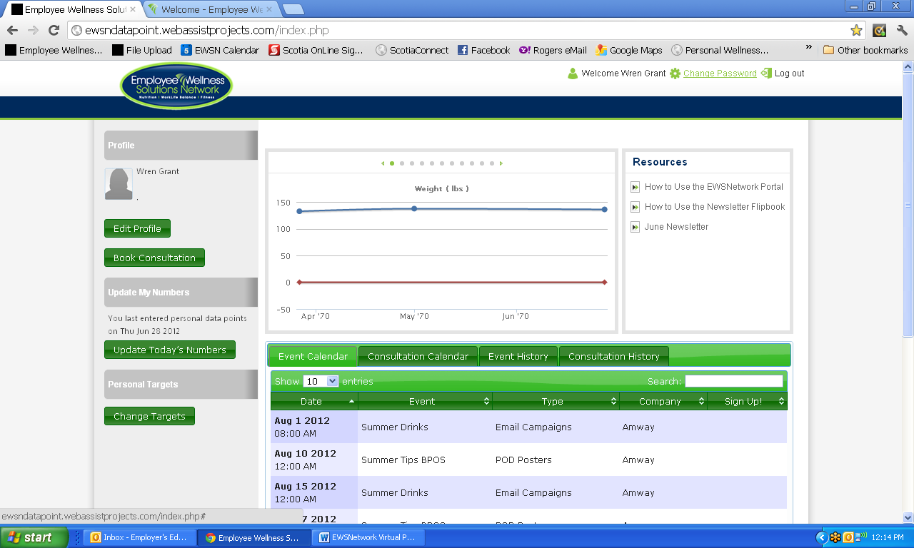

**User Dashboard**

**(Start Time – 1:30)**

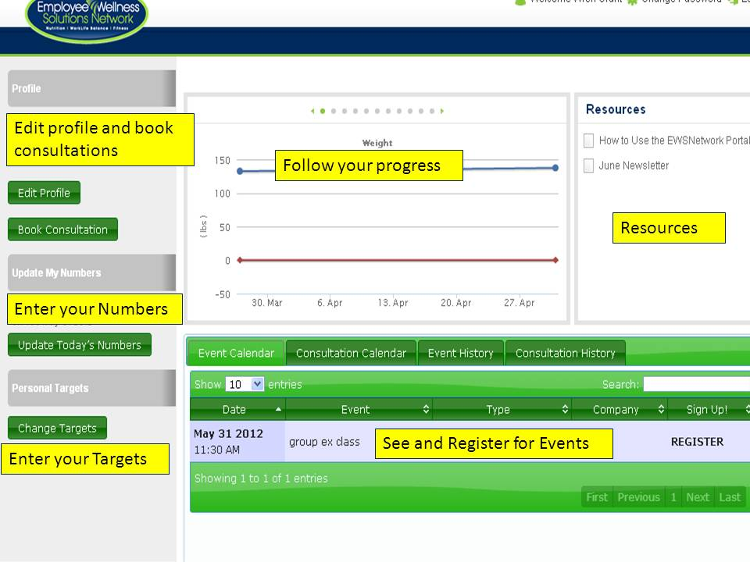

**Through the dashboard you are able to:**

**Edit your Profile**

**(Start Time - 1:50)**

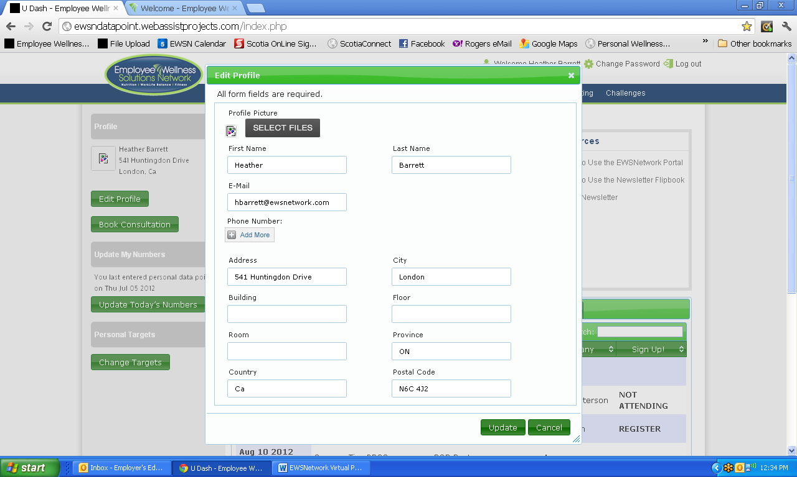

**Book a Consultation**

**(Start Time – 2:14)**

**Step 1** - Pick the consultant and click **NEXT**.

**Step 2**.- This will bring up the Consultant’s schedule.

All available appointments will be in bold (see below)

**Step 3** - Select 3 appointment times by clicking the timeframe

and then click **SUBMIT**.

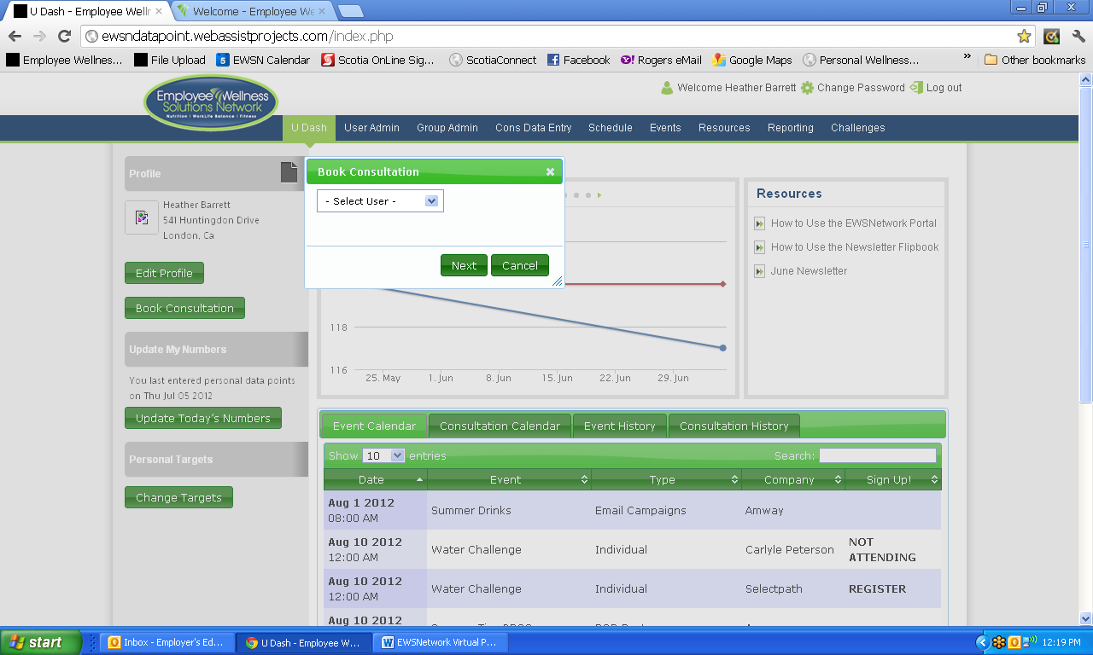

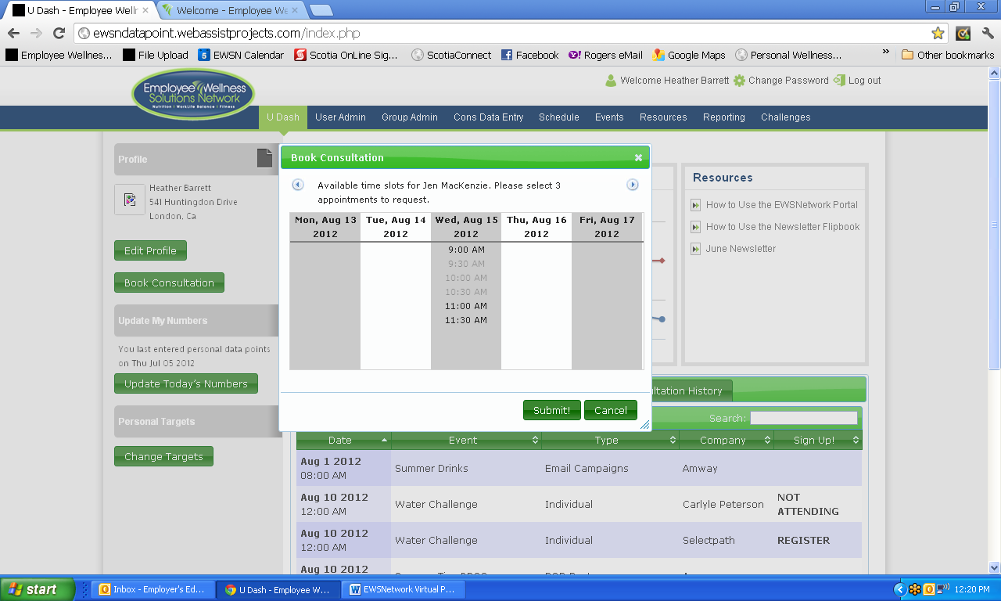

**Set Your Targets**

**(Start Time – 3:08)**

You can set targets for yourself.

Your progress is indicated as a red line on your various graphs.

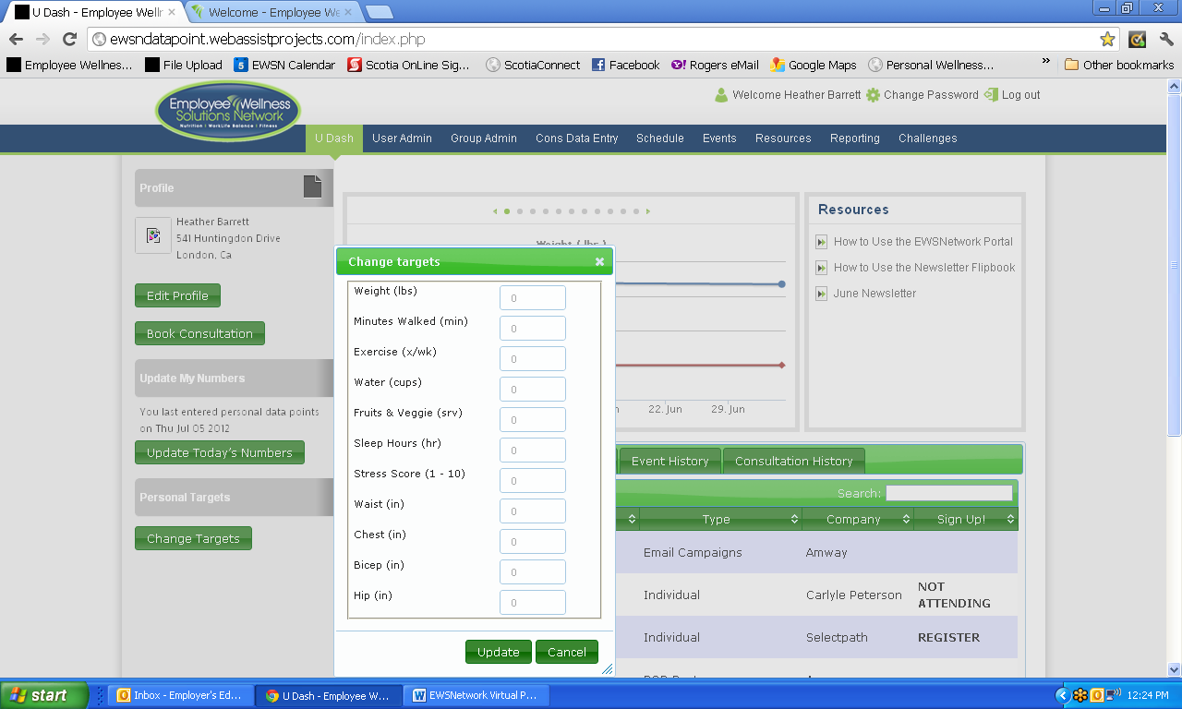

**Enter your Numbers**

**(Start Time – 3:36)**

You can track your weight, minutes walked, water intake, fruits & veggie servings,

hours slept, stress level and body measurements.

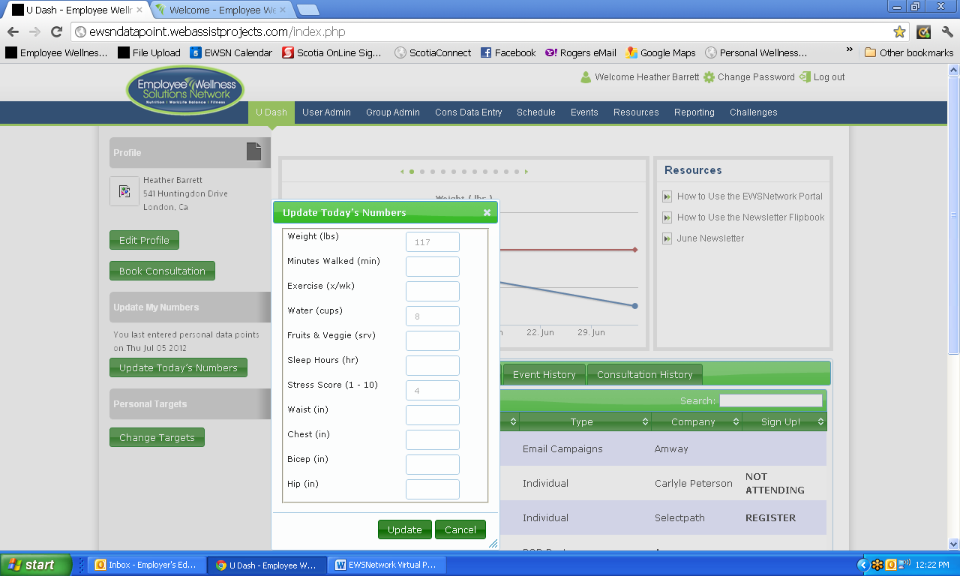

**Track Your Progress**

**(Start Time – 3:57)**

When you input your numbers, for the above criteria, your progress will show on the graph.

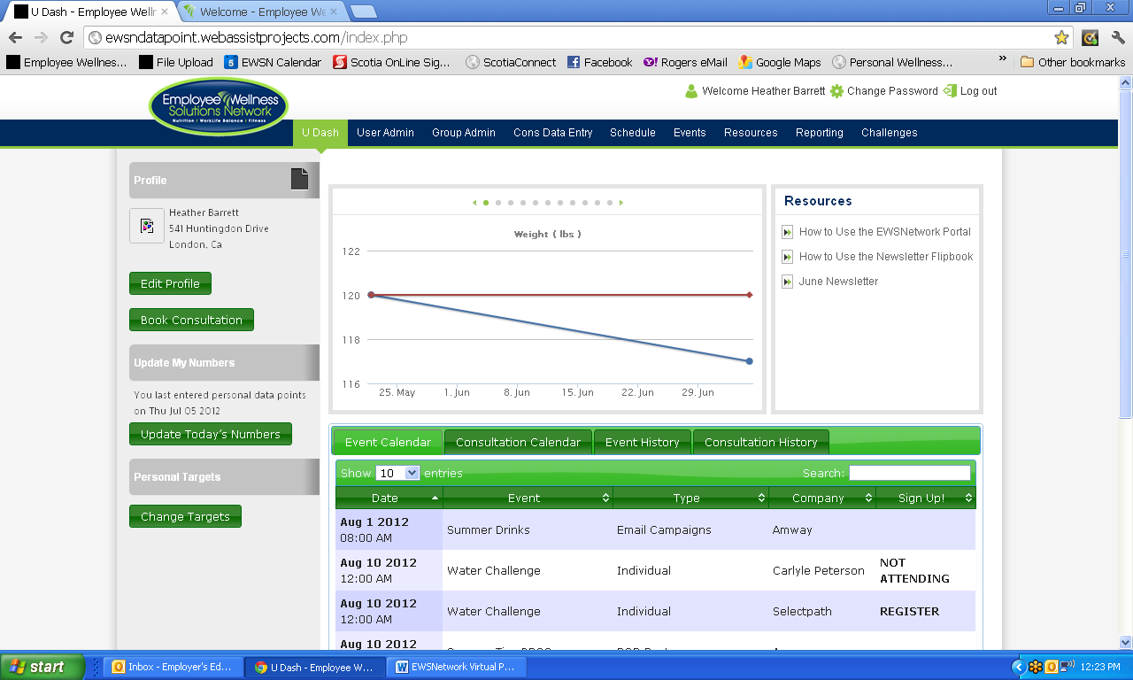

**See and Register for Upcoming Events**

**(Start Time – 4:30)**

* You are able to search for specific events by typing in the event type, name, date in the search box.
* You will also be able to see history of events and consultations through the appropriate tabs.
* If you roll over the Event Name, a description of the event will pop up for you to read as seen below.
* The event calendar is at the bottom of the User Dashboard. If you would like to participate in an upcoming event simply click REGISTER beside the event. It will then show on your dashboard as ATTENDING. If you need to cancel your registration, prior to the event, click ATTENDING once and it will change to show NOT ATTENDING.

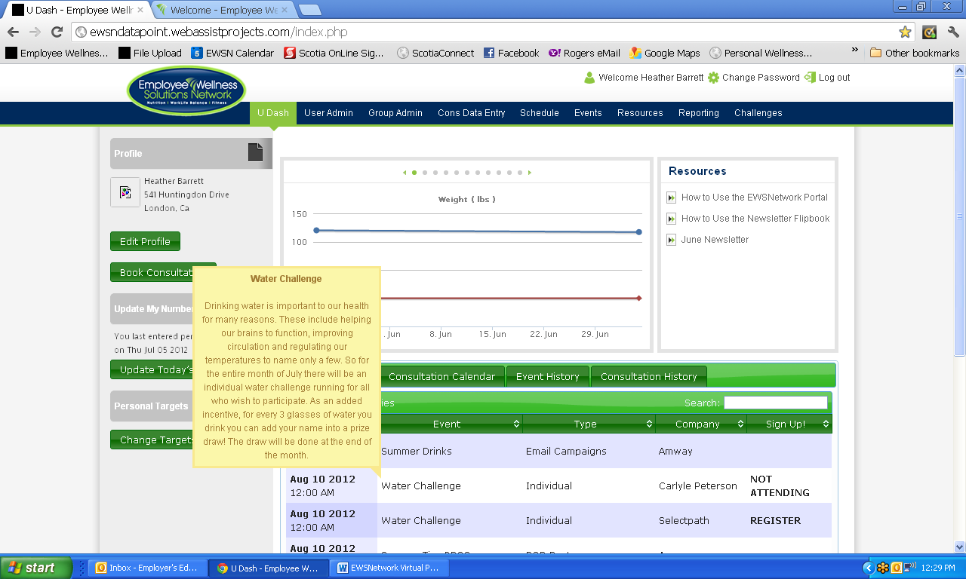

**Access Resources**

**(Start Time – 5:42)**

At the top right hand side of the Dashboard, you will have

access to various resources provided by EWSNetwork. To view simply click the link.

