Fast Food Scramble
Place the fast food items in order of LEAST FAT to MOST FAT by writing the appropriate number beside the item (1 = least fat, 5 = most fat).
___2____ | 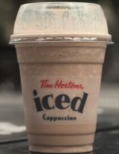  Large Iced Cap [20g]  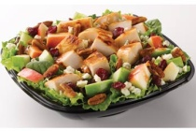  Wendy’s Apple Pecan Chicken Salad [27g]  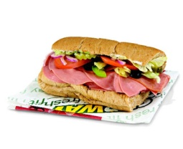  Subway 6” Cold Cut Sub [17g]  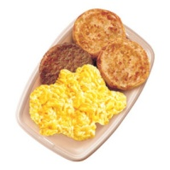  McDonalds Big Breakfast with Hashbrown [39g]  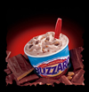  Dairy Queen Large Skor Blizzard [50g]
____3___
___1____
____4___
___5____

