
Company NAME:

MONDAY, June 15 – SUNDAY, June 28

Did you know that stretching can be beneficial? Stretching helps…
- Reduce muscle tension
- Increase range of movement in joints
- Enhance muscular coordination
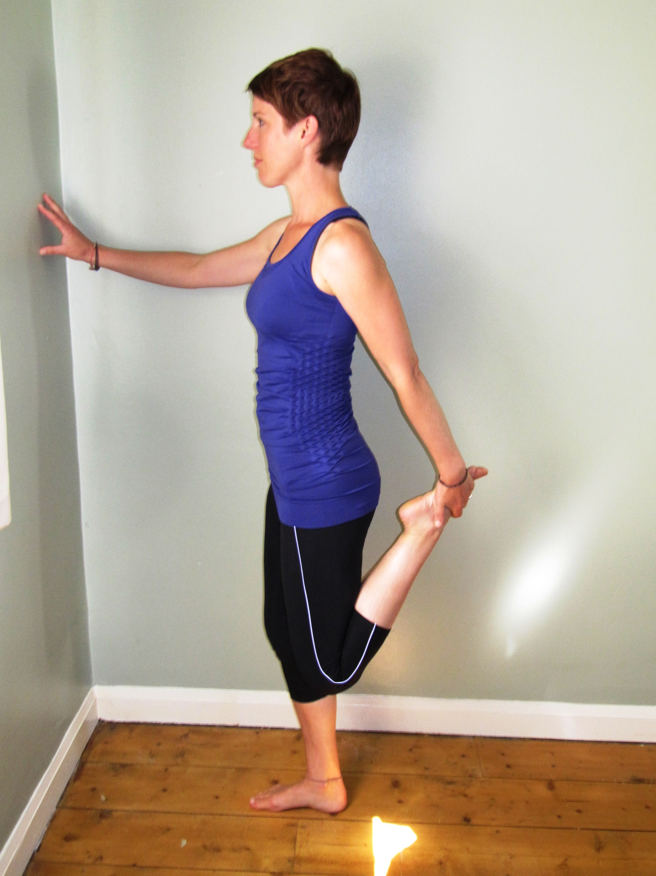
- Increase circulation of the blood to various parts of the body
- Increase energy levels (resulting from increased circulation)
- Improve sleep
- Enhance relaxation
- Prevent injury

This challenge will encourage you to stretch!
- For the next two weeks, please complete the stretches on your individual log sheets.
- Each time you complete an exercise, award yourself with 2 points.
- NECK ROLLS and SHOULDER ROLLS – 5 rolls each way = 2 points
- ALL OTHER EXERCISES – hold for 5 seconds each side = 2 points
- Each day, please tell/email your team captain your total points for completing the exercises.
- Don’t forget the weekends!
- Final results will be tallied on MONDAY, June 29

