Name:___________________________ Team #______ Ext #____________

Please give yourself 2 points each time you do the illustrated
exercise 5 times (movement) or hold for 5 seconds (one position).
E-mail your total points to your team captain everyday for the next 1-2 weeks.
DATE: | Mon. | Tues. | Wed. | Thurs. | Fri.
Neck Rolls
Shoulder Stretch
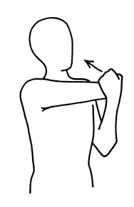
Shoulder Rolls
Chair Side Bend
Chair Torso Rotation
Quad Stretch
Back Stretch
Wrist Stretch
Total Points =

