Lunch n' Learn
The Power of Positive Thinking
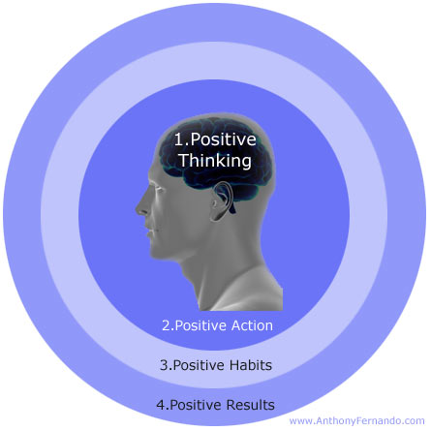

©2012 Employee Wellness Solutions Network –Power of Positive Thinking, All Rights Reserved.
restore, rejuvenate and recharge every facet of your life by how you think!

Monday, September 14th 2009

Program Information

DATE: Monday, September 14th

WHEN: 12:00 – 1:00 p.m.

WHERE: Boardroom

