
Pancake Breakfast

High Protein Apple Cinnamon Pancake Recipe
Nutrition Nugget: This recipe is high in protein, low in sugar, low in sodium, contains considerable fibre, and is high in healthy, Omega fats.
Serves: 7
Ingredients:

- 2/3 cup pancake mix
- 2/3 cup oatmeal
- 4 tbsp ground flax
- 1 egg
- 1.5 cups skim milk [adjust accordingly to desired consistency]
- 1 tbsp cinnamon
- 2 peeled and chopped apples

Directions:
Mix together dry ingredients: pancake mix, oatmeal, ground flax and cinnamon. In a small bowl, whisk together wet ingredients: milk and eggs. Pour wet ingredients into dry ingredients and gently mix together – careful not to over-mix. Finally, add in the chopped up apples and stir together.

Place a non-stick frying pan or griddle over medium heat. When a drop of water sizzles as it hits the pan, spoon 1/2 cup pancake batter into the pan. Cook until the top surface of the pancake is covered with bubbles and the edges are lightly browned, about 2 minutes. Turn and cook until the bottom is well browned and the pancake is cooked through, 1 to 2 minutes longer. Repeat with the remaining pancake batter.

Nutritional Information Comparison:

Serving: 1 pancake

 | High Protein Pancake | Traditional Pancake
Calories | 180 | 315
Protein | 6 g | 1 g
Carbohydrate | 30 g | 60 g
Sugar  Fibre  Total Fat | 6g  5g  4 g | 12g  1g  13 g
Cholesterol | 22mg | 77 mg
Sodium | 125 mg | 581 mg

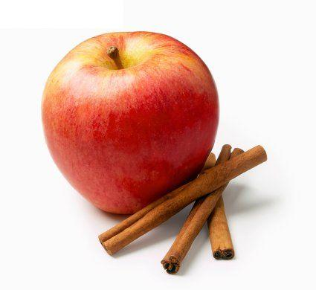

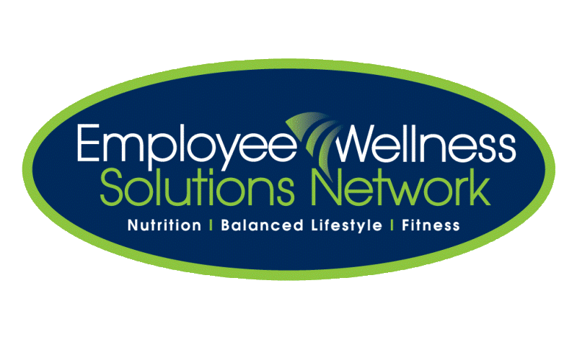
Ways to make the recipe higher protein, lower fat, and lower in cholesterol: add protein powder and egg whites [in place of whole egg]. Adjust milk for desired consistency.

©2011 Employee Wellness Solutions Network – All Rights Reserved.

