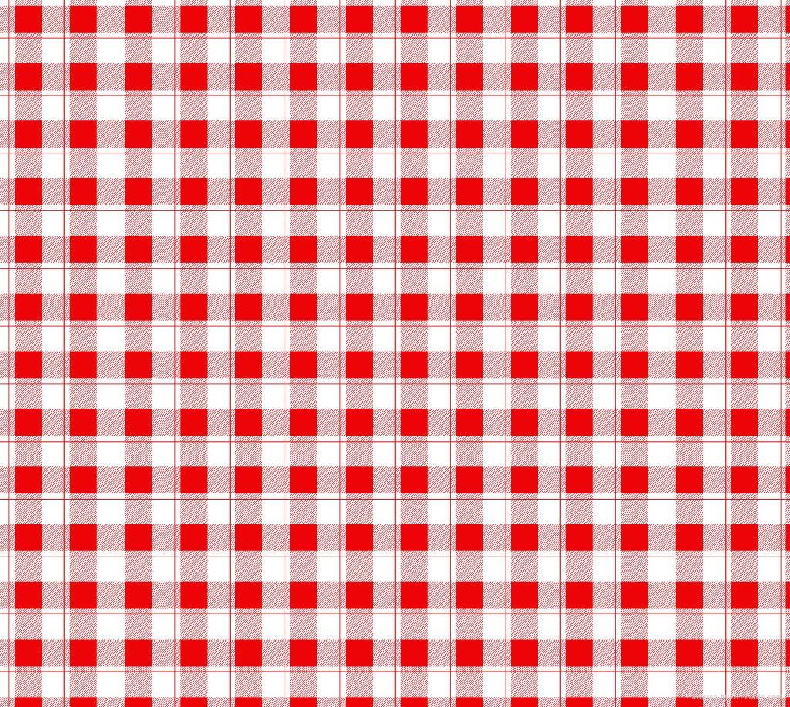 **Summer d r i n k s Recipes**

**Week 2:** Iced Mint Green Tea

**Fluid Fact #2: How Much Water Do I Really Need?**

* National Institute of Medicine recommends ~ **3 L** of fluid for males, and **2 L** for females. The general recommendation for eight 8 oz of water is ~ 1.9 L.
* The best way to check if you are drinking enough water is to **check your urine**. If your urine is pale to very clear, you are well hydrated. Darker, more concentrated urine suggests you may be dehydrated.

*Out of the three main types of tea – black, oolong and green, “green tea is the* ***least processed*** *and thus* ***provides the most antioxidant polyphenols (EGCG),*** *which is believed to be responsible for* ***most of the health benefits****.” (*[*http://www.whfoods.com/*](http://www.whfoods.com/)*)*

**Iced Mint Green Tea**

* 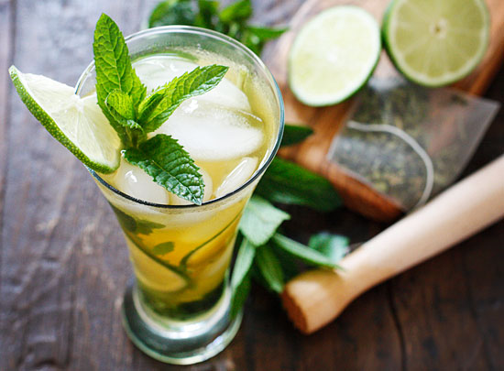½ cup fresh mint leaves
* 3 green tea bags
* 2 tbsp honey
* 4 cups boiling water
* 2 cups sake, divided

4 stalks lemongrass, for garnish

**Directions**

1. Combine mint leaves, tea bags, honey and boiling water. Let steep for 5 minutes; remove tea bags. Refrigerate until chilled.
2. Divide among 4 large ice-filled glasses. Add 1/2 cup sake to each glass. Garnish with a stalk of lemongrass. Non-alcoholic variation: Omit the sake.

|  |  |  |  |
| --- | --- | --- | --- |
| **Nutritional Information (per serving)** | | | |
| **Calories** | **76** | **Potassium** | **67 mg** |
| **Protein** | **1 g** | **Cholesterol** | **0 mg** |
| **Carbohydrate** | **11 g** | **Sodium** | **11 mg** |
| **Total Fat** | **0 g** | **Fiber** | **1 g** |
| **Saturated Fat** | **0 g** | **Makes 4 servings** | |

Resources: <http://www.eatingwell.com/>, <http://whfoods.com>, <http://eatdrinkbetter.com/>