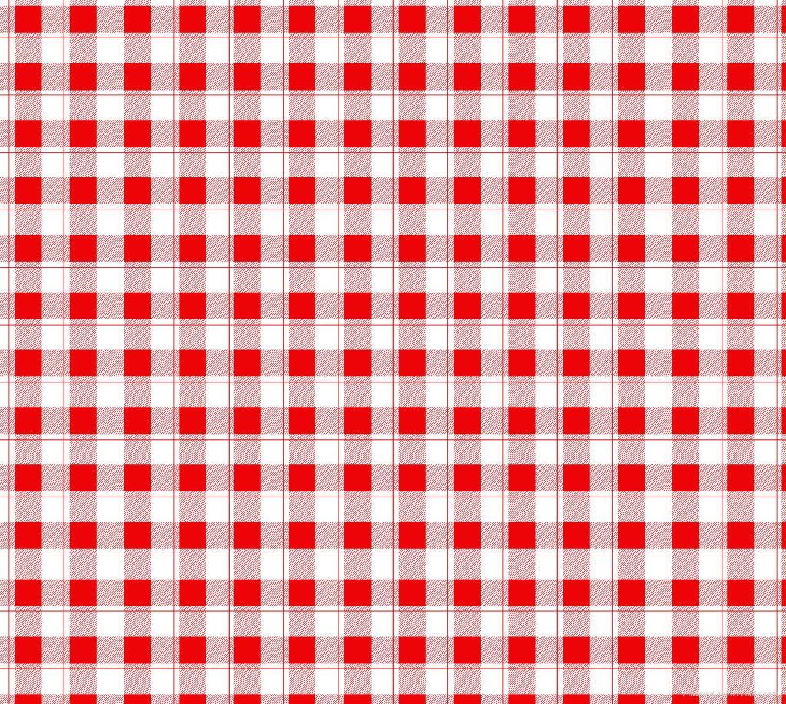 **Summer d r i n k s Recipes**

**Week 1:** Bloody Mary with Shrimp

**Fluid Fact #1: Sodas and Sodium**

* Sodas, BOTH regular and diet can contain a lot of sodium. Coke, Diet Coke, Pepsi, and Diet Pepsi all contain about 35 mg of sodium per 8 oz (1 can = 12 oz).
* Diet Root Beer contains (100 mg) more sodium than regular Root Beer (65 mg) per 8 oz serving.

*An 8 oz serving of V8 vegetable juice contains only 51 calories, an ideal way to reach Canada’s Food Guide recommendation of* ***7-8*** *servings of fruits and vegetable for females, and* ***8-10*** *for males. However, 8 oz of V8 contains* ***480 mg*** *of sodium (20% Daily Value) – be sure to get the Low Sodium V8.*

**Bloody Mary with Shrimp**

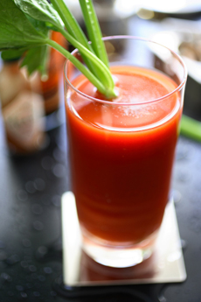

22 oz (2 cans) reduced-sodium V8

1 tsp horseradish

1 tsp Worcestershire sauce

1 tbsp lemon juice

10 dashes Tabasco

Freshly ground pepper, to taste

3 oz vodka, optional

Ice cubes

4 cooked shrimp

**Directions**

1. Shake V8, horseradish, Worcestershire sauce, lemon juice, Tabasco, pepper and vodka, if using, in a large glass jar with a tight-fitting lid.
2. Fill two tall glasses with ice and divide the Bloody Mary between the glasses. Garnish each drink with 2 shrimp.

|  |  |  |  |
| --- | --- | --- | --- |
| **Nutritional Information (per serving)** | | | |
| **Calories** | **78** | **Potassium** | **681 mg** |
| **Protein** | **2 g** | **Cholesterol** | **0 mg** |
| **Carbohydrate** | **17 g** | **Sodium** | **284 mg** |
| **Total Fat** | **0 g** | **Fiber** | **3 g** |
| **Saturated Fat** | **0 g** | **Makes 2 servings** | |

Resources: <http://www.eatingwell.com/>, <http://www.livestrong.com/>, <http://thetriton.com/>