** Summer d r i n k s Recipes**

**Week 3:** Kahluacinno

**Fluid Fact #3: Caffeine and Dehydration**

* Researchers concluded it is **better** to drink caffeinated drinks than no fluids at all, especially when exercising on a hot day.
* Caffeine increases the amount of urine production and increases the loss of electrolytes through sweat, but these effects are not enough to affect dehydration or blood electrolyte levels.

*Did you know an 8 oz serving of McDonald’s Iced Coffee contains* ***more calories*** *than an 8 oz serving of Coca-Cola (132 calories and 90 calories respectively),* ***more sodium*** *(40 mg and 31 mg respectively), and* ***almost the same amount of sugar*** *(21.2 g and 25 g respectively).*

**Kahluacinno**

* 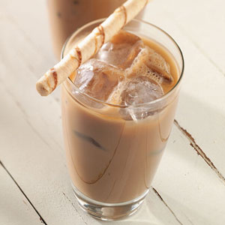
* ¾ cup nonfat milk
* ¾ cup strong coffee
* ½ cup Kahlua, or Frangelico
* 3 cups ice
* 4 tsp sugar
* Shaved chocolate, for garnish

**Directions**

1. Combine milk and coffee in a blender. Add Kahlua (or Frangelico), ice and sugar. Puree until frothy.
2. Divide among 4 glasses and garnish with shaved chocolate. Non-alcoholic variation: Omit the alcohol and add 1/4 teaspoon almond extract.

|  |  |  |  |
| --- | --- | --- | --- |
| **Nutritional Information (per serving)** | | | |
| **Calories** | **138** | **Potassium** | **100 mg** |
| **Protein** | **2 g** | **Cholesterol** | **1 mg** |
| **Carbohydrate** | **20 g** | **Sodium** | **27 mg** |
| **Total Fat** | **0 g** | **Fiber** | **0 g** |
| **Saturated Fat** | **0 g** | **Makes 4 servings** | |

Resources: <http://www.eatingwell.com/>, <http://thetriton.com/>, <http://www.calorieking.com>