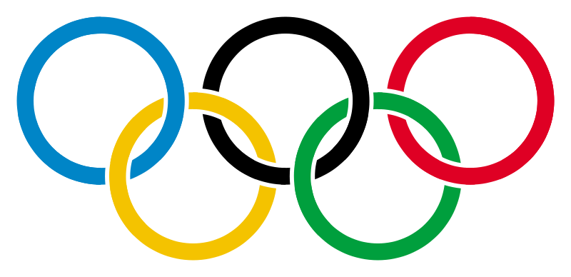

Own the Podium
Own the podium by completing as many tasks as possible and getting the most number of medallions!

BRONZE Tasks

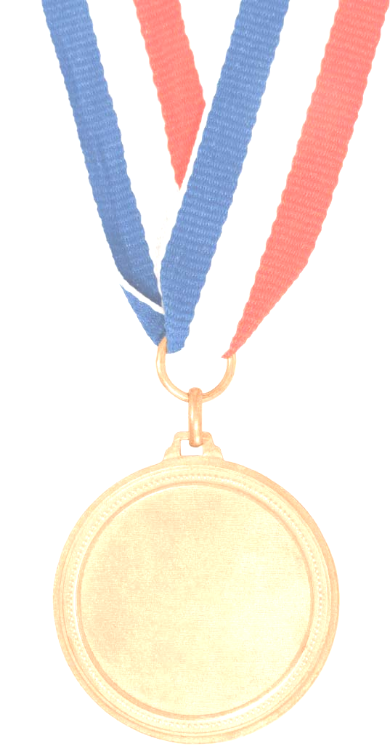
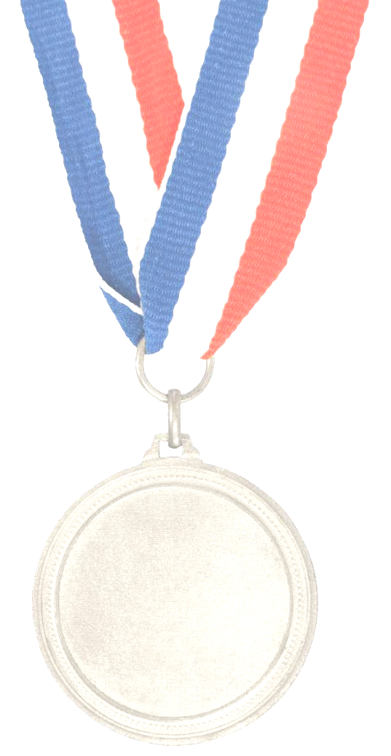
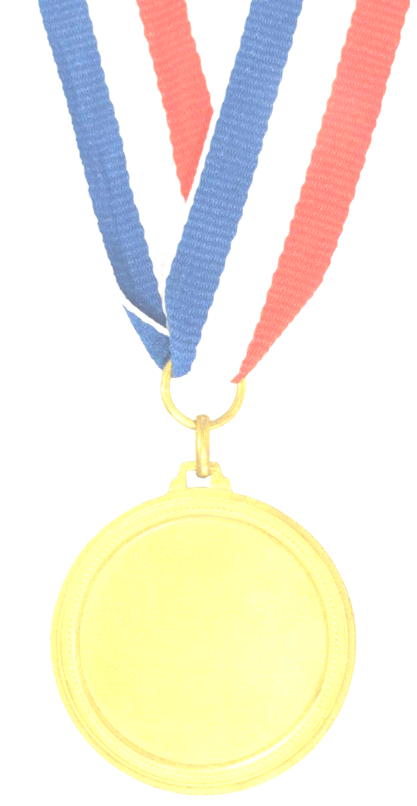
Ate breakfast with 1 fruit and 1 grain product | Did 10 push ups | Did 20 shoulder rolls, both ways today
Accumulated 3,000 steps or walked for  20 min today | Had 10 min of “me” time (read, shop, run, massage) | Swapped coffee with Green tea or water today
Did at least  20 min of resistance exercise | Ate a healthy snack (almonds, yogurt, fruit) | Ate at least 2 servings of dark green vegetables
Held a side neck stretch for 10 sec TWICE today | Drank 4 glasses of water today | Completed a wall squat for 30 sec
Parked my car as far away as possible at work | Ate 1 serving of meat alternatives (tofu, eggs, beans) | Took 10 deep breaths TWICE today
Ate 3 servings of whole grains with at least 4 g of fibre/serving | Went for a walk after dinner for at least 20 mins | Drank 8 glasses of water today
Accumulated 10, 000 steps or walked 60 min today | Booked my yearly physical | Ate a serving of cereal with <6 g of sugar
Did 20 min of high intensity cardio and 20 min of weights | Prepared my  meals and snacks the night before | Ate salad with beans and 3 servings of vegetables
Tried a new recipe | Had a Green Monster smoothie (spinach, banana, OJ, yogurt, ice) | Climbed 6 flights of stairs today
Rode my bike to work today | Made a family dinner with at least 2 colors of vegetables | Booked or attended a wellness consultation
Drank 6 glasses of water today | Did 10 push ups and 10 sit ups | Held a calf stretch for 20 sec TWICE today
Accumulated 5, 000 steps or walked for 30 min today | Had 20 min of “me” time  today | Did not drink coffee after 3pm today
Did at least 20 min of cardio (jog, swim, cycle) | Ate a healthy snack TWICE today  [mid-am and mid-pm] | Ate salad with 3 different colours (ex. green, red, yellow)
Did an exercise class | Consumed 2 low-fat dairy products (milk, yogurt) | Completed 10 walking lunges back and forth
Compliment-ed two co-workers today | Ate at least ½ cup of beans today | Wrote down 5 family wellness goals for 2012

After completing a task, please post a corresponding medallion under your team flag.
BRONZE tasks = 1 point; SILVER tasks = 5 points; GOLD tasks = 10 points
1

©2012 Employee Wellness Solutions Network™ - Own the Podium, All rights reserved.
SILVER Tasks

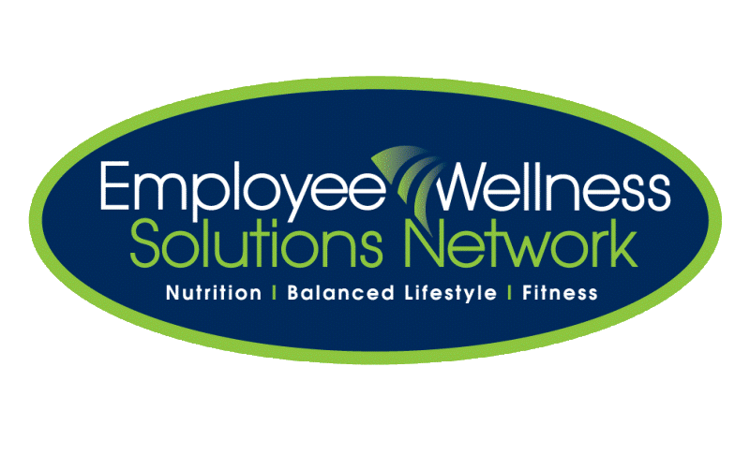

GOLD Tasks

