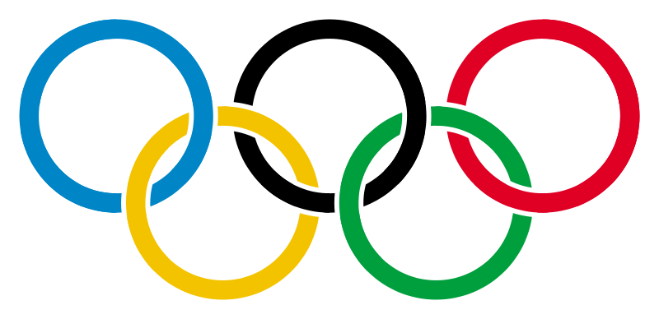

**Own the podium**

 EWSNetwork 2012 Olympics Instructions

**DATES: MONDAY, JUNE 18TH – FRIDAY, JUNE 29TH**

This challenge will kick you into full gear for the 2012 Summer Olympics. It will encourage you to **eat healthy**, be **active**, reduce **stress**, and work as a **team** to own the podium!

* Teams will be organized per department. Team captains will be pre-determined. As a team, you will select a team country.
* Beginning **Monday, June 18th**, in each of the kitchenettes, you will see your team flag and a poster card with **three** different categories of tasks.
* Each task card corresponds to a difficulty level – easy, medium, hard. Completion of each task is awarded a **Bronze, Silver and Gold** medallion, respectively.
* Each member can choose the tasks he/she would like to complete.
* After completion of a task, you may obtain a **medallion** corresponding to the difficulty level of the task (easy: bronze, medium: silver, hard: gold) in the provided envelopes. Simply stick the medallion under your team Country’s Flag.
* The team who accumulates the most number of medallions and corresponding points by **Friday, June 29th WINS**!
* Winning team wins bragging rights and Berry Yogurt Parfaits!

