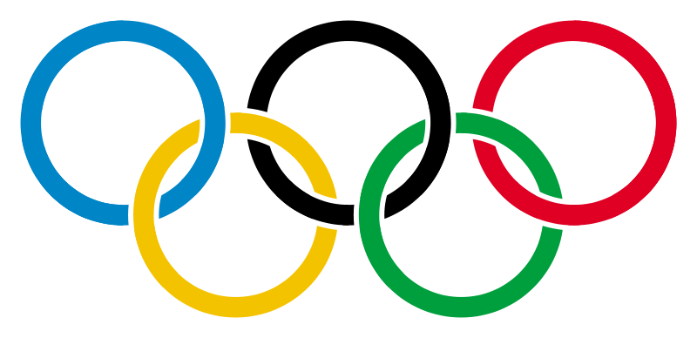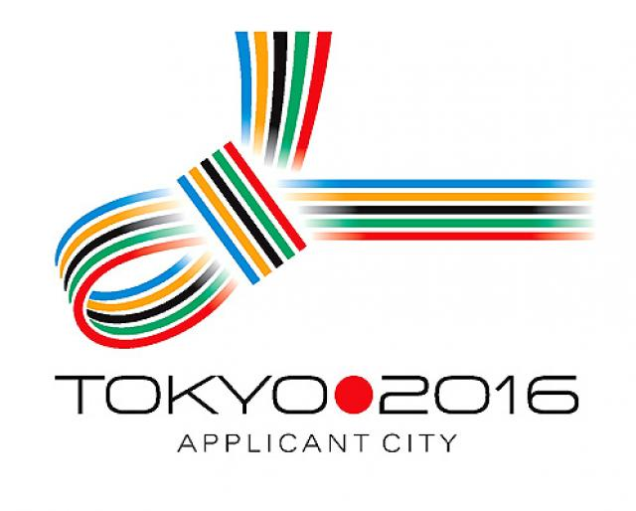 **Own the Podium**

 Strengthen the Body

In preparation for the Olympics, athletes need to do the necessary training in order to be strong enough of compete and win.

In order to ensure muscles are primed, athletes need to work all areas of the body.

Please complete the following Olympic full-body workout.

1. Choose four members of your team and all complete a plank on the floor. Hold it for at least 30 seconds each. Somebody time them!

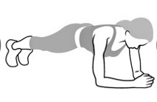

1. Choose four members of your team and complete 15 push ups each [on the floor using your toes or knees]. Somebody count for them!

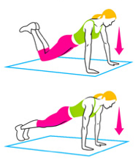

1. Choose four members to complete 15 squats each.
2. Choose four members to complete 15 tricep dips using a chair.