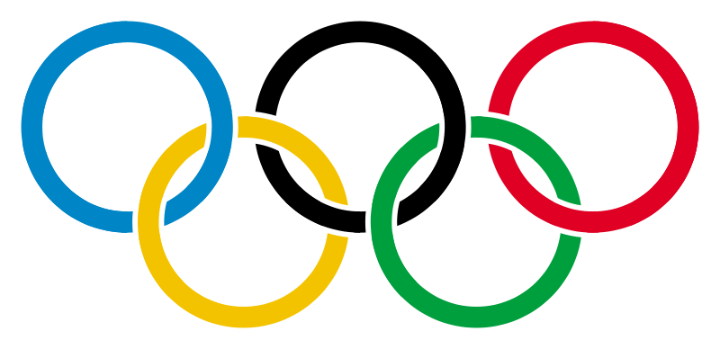 **Own the Podium**

 Kids-At-Heart

Athletes are kids-at-heart. They love games and competition.

Completing a puzzle is both fun and rewarding for kids.

There are TWO puzzles in the room. Find and complete ONE.

There is a hidden message. Solve it.

What does it mean?

**________________________**

**Unscramble the puzzle, replace it in its box, and return it to where you found it.**