**Antioxidants**

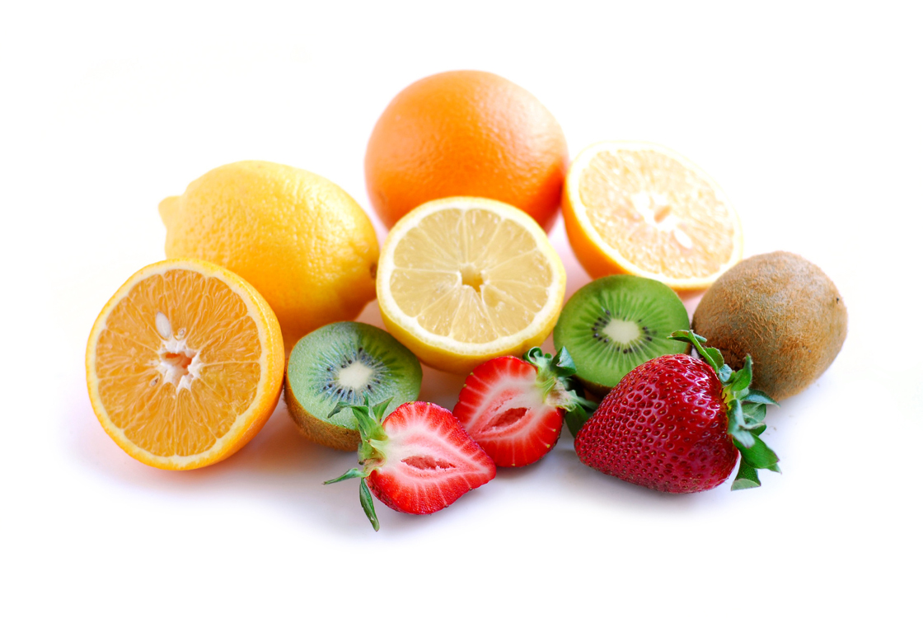

Power House for

**Your** Health

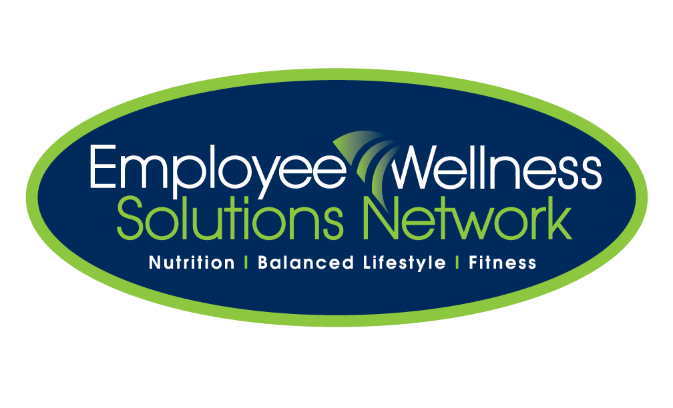

**Brought to you by:**

**What are Antioxidants?**

Antioxidants are substances that may **protect cells from damage caused by free radicals** (unstable molecules). Antioxidants interact with and neutralize free radicals by preventing damage from free radicals that may lead to cancer.

It is impossible for us to avoid damage by free radicals. That is why antioxidants are critical and must be replenished.

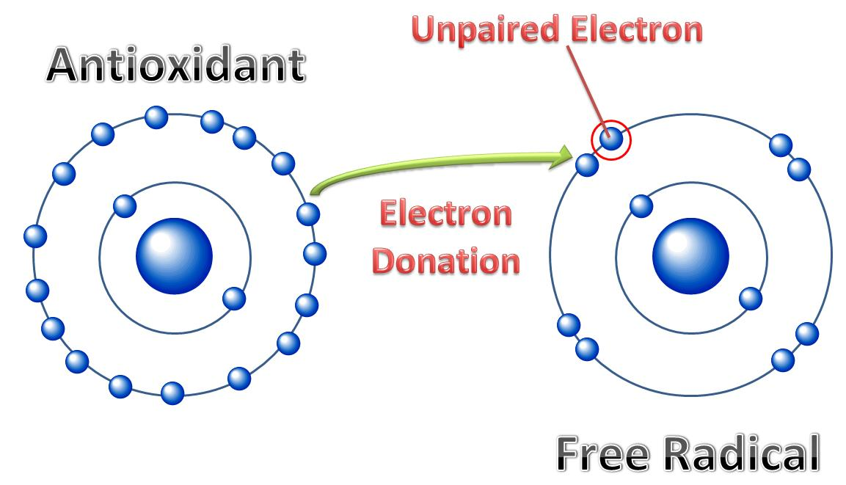

**Which Foods are Rich in Antioxidants?**

|  |  |
| --- | --- |
| **BETA-CAROTENE** | * Sweet potatoes, carrots, cantaloupe, squash, apricots, pumpkin, mangos. * Collard greens, spinach, kale. |
| **LUTEIN** | * Collard greens, spinach, kale. |
| **LYCOPENE** | * Tomatoes, watermelon, guava, papaya, apricots, pink grapefruit, blood oranges. |
| **SELENIUM** | * Component of antioxidant *enzymes*, not an antioxidant *nutrient* * Rice, wheat, meat, Brazil nuts. |
| **VITAMIN A** | * Liver, sweet potatoes, carrots, milk, egg yolks, mozzarella cheese. |
| **VITAMIN C** | * Cereal, beef, poultry, fish. * Oranges, raw peppers, strawberries, papaya, broccoli. |
| **VITAMIN E** | * Safflower oil, corn oil, soybean oil, sunflower oil * Wheat germ, mangos, nuts, broccoli, sunflower seeds, almonds, bran cereal. |

**Antioxidants and Disease Prevention**

Evidence from various studies indicates that **antioxidants may slow or possibly prevent the development of cancer**.

**“If free radical damage is not stabilized by antioxidants, it may become irreversible and lead to disease including cancer.”**

Observational studies (looking for associations without supplements) have linked diets rich in antioxidant-rich fruits and vegetables to a lower risk for diseases like **cancer, heart disease, stroke, cataracts, Parkinson’s, Alzheimer’s, and arthritis.**

**Put it into Practice!**

* Aim to reach **5-10 servings of vegetables and fruit every day**.
* Choose the most **colourful veggies, fruits and juices**. Dark green, red and orange vegetables pack in the most amounts of beta-carotene, lutein or lycopene.
* Vitamin C is lost during storage time and when it is cooked in water. Try to eat fruits and vegetables when they are **fresh and raw**, as much as possible.
* **Vegetable oil** is an excellent source of Vitamin E! Sunflower, canola, safflower, and olive oil are great choices.

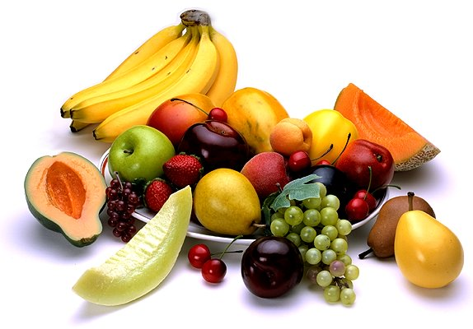

**Antioxidant Tips and Recipes**

**VITAMIN C**

* **Stir-fry**: Broccoli/spinach/Brussels sprouts, sweet peppers, meat.
* **Yogurt**: Add strawberries, raspberries to low-fat yogurt.
* **Tropical Smoothie**: mangos/guava/papaya with yogurt and orange juice.

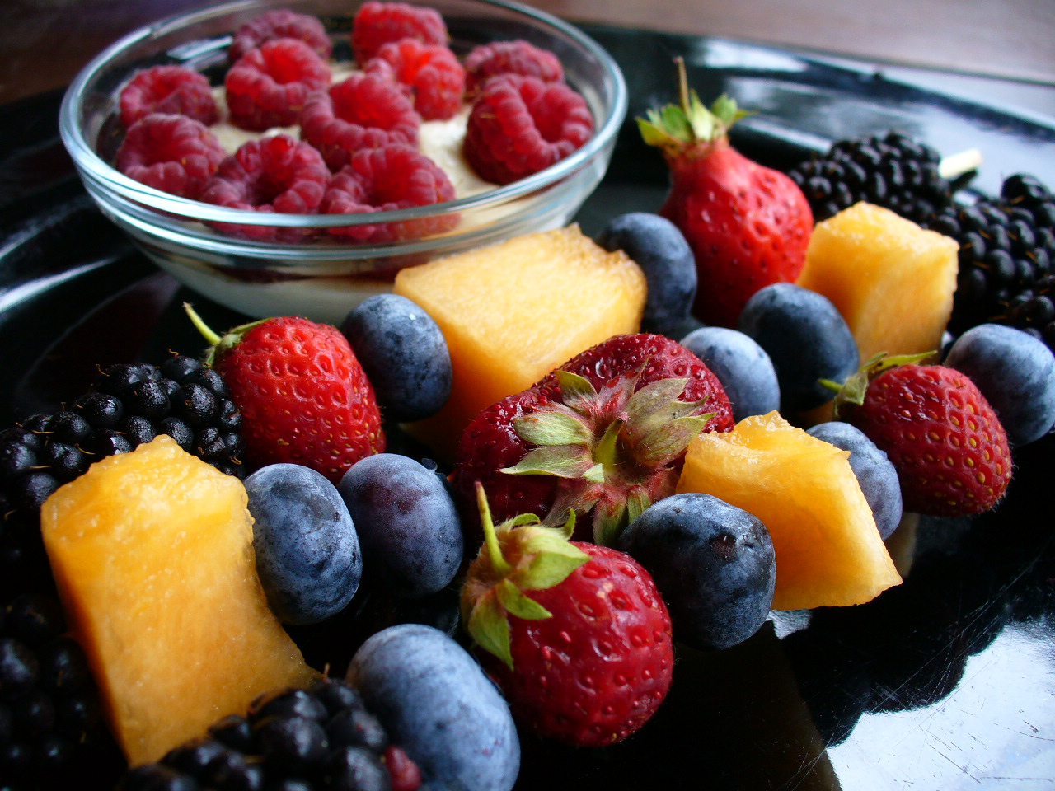

**VITAMIN E**

* Sprinkle almonds and sunflower seeds on salads, granola, or cereal.
* Spread almond or natural peanut butter on whole grain bread.
* Add avocados to salads, sandwiches, wraps, and smoothies.
* Add wheat germ to muffins, loaves, and pancakes.
* **Fish tacos**: mackerel/herring/salmon/halibut/tuna, tortillas, guacamole, tomatoes.

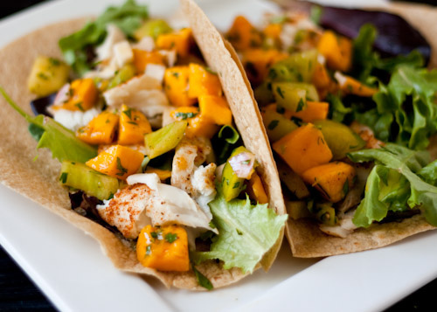

**FLAVONOIDS**

* Swap coffee for green tea
* Add apples and red grapes to a salad or wrap.
* **Berry Smoothie**: blueberries, strawberries, frozen yogurt, skim milk, flax.

**SELENIUM**

* **Mixed Bean Salad**: Mixed beans, corn, celery, orzo, lemon vinaigrette.
* **Roasted Chick Peas**: Roast canned chickpeas thoroughly rinsed and dried for 20 min at 350 degrees.

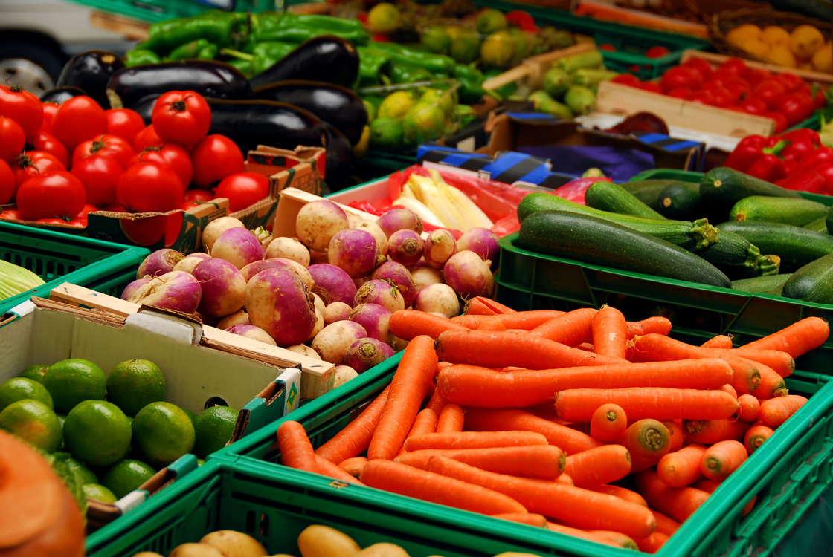

**CAROTENOIDS**

* Roast carrots, sweet potatoes, or squash.
* Have tomato sauce over whole wheat pasta or brown rice.
* **California Spinach Salad**: baby spinach, strawberries, almonds, avocado, chicken.

