**Antioxidants and Cancer Prevention**

**What are Antioxidants?**

Antioxidants are substances that may **protect cells from damage caused by free radicals** (unstable molecules). Antioxidants interact with and neutralize free radicals by preventing damage from free radicals that may lead to cancer. It is impossible for us to avoid damage by free radicals. That is why antioxidants are critical and must be replenished.

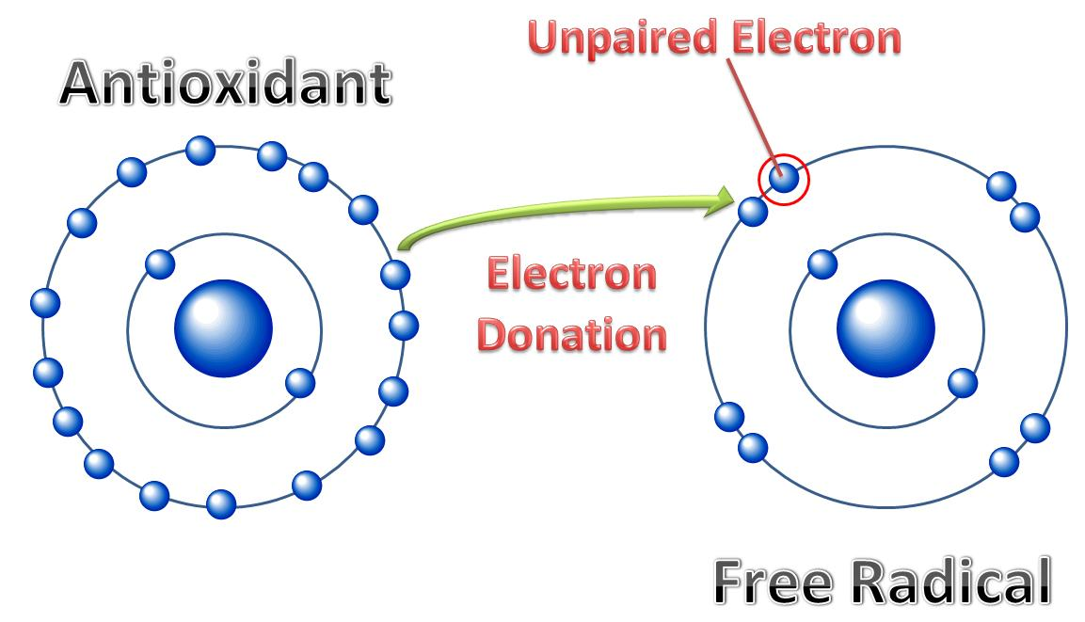

“If free radical damage is not stabilized by antioxidants, it may become irreversible and lead to disease including cancer.”

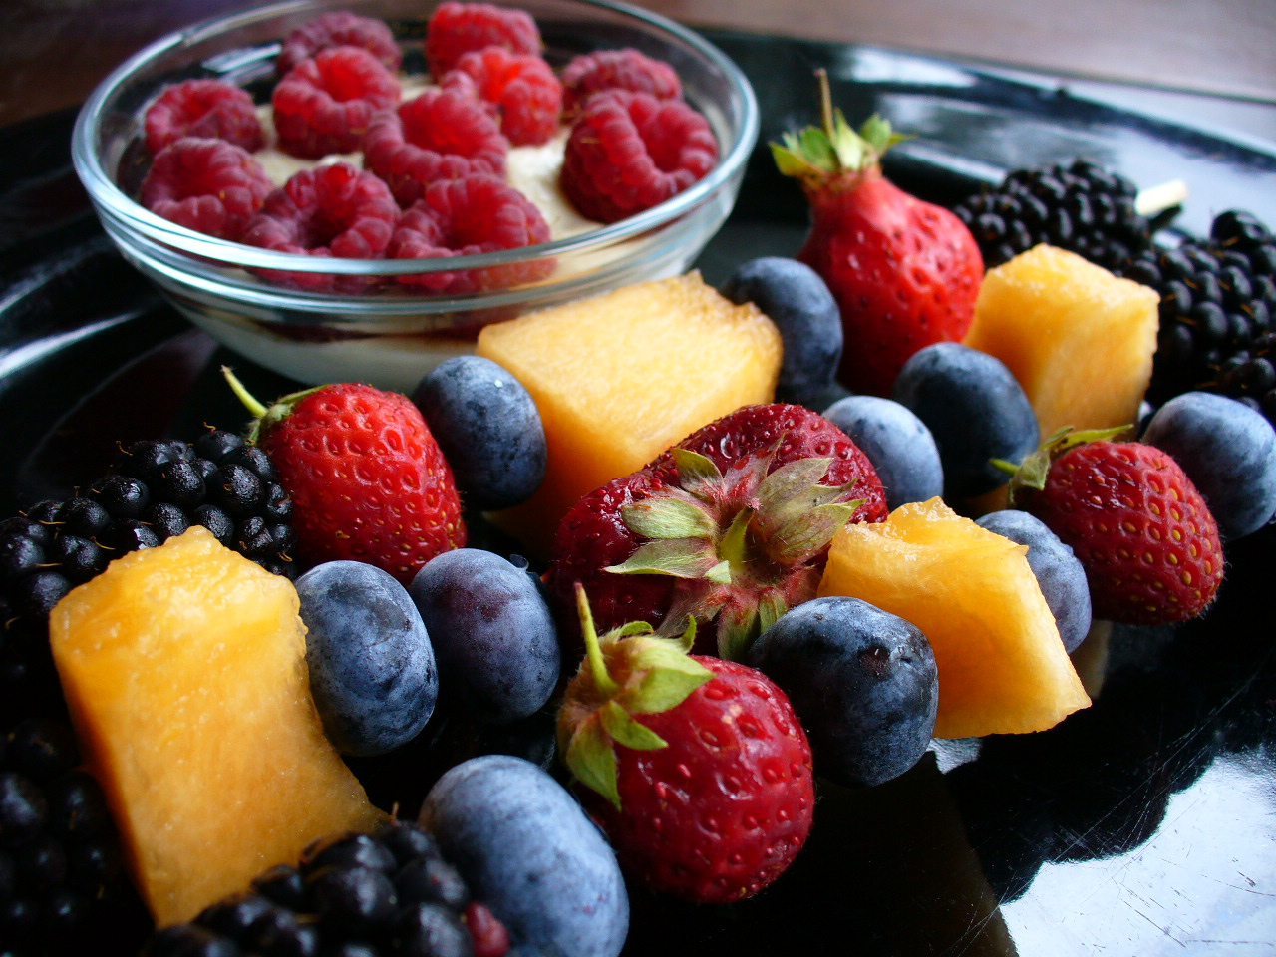**Disease Prevention**

Evidence from various studies indicates that **antioxidants may slow or possibly prevent the development of cancer**.

Observational studies (looking for associations without supplements) have linked diets rich in antioxidant-rich fruits and vegetables to a lower risk for diseases like **cancer, heart disease, stroke, cataracts, Parkinson’s, Alzheimer’s, and arthritis.**

**How Much Should I Eat?**

“Vitamin C, Vitamin E, Selenium, Beta-Carotene should come from *food*, not *supplements*.”

American Heart Association suggests, **“people should eat a variety of foods daily from all the food groups … not antioxidant supplements.”**

Consuming mega-doses of antioxidants can be harmful due to their potential toxicity and interactions with medications. Extremely high doses may lead to health problems including diarrhea, bleeding, and risk of toxic reactions.

**Green Tea and Antioxidants**

“Green tea is the least processed and thus **provides the most antioxidant polyphenols,** which is believed to be responsible for **most of the health benefits.**”

Green tea is particularly rich in health-promoting flavonoids including EGCG. EGCG is thought to play a **pivotal role in anticancer and antioxidant effects**.

**HOW MUCH?** Just 1 cup of green tea supplies 20-35mg of EGCG – the highest antioxidant activity of all the green tea flavonoids.

**Antioxidant-Rich Foods**

|  |  |  |
| --- | --- | --- |
| **BETA-CAROTENE** |  | * Sweet potatoes, carrots, cantaloupe, squash, apricots, pumpkin, mangos. * Collard greens, spinach, kale. |
| **LUTEIN** |  | * Collard greens, spinach, kale. |
| **LYCOPENE** |  | * Tomatoes, watermelon, guava, papaya, apricots, pink grapefruit, blood oranges. |
| **SELENIUM** |  | * Component of antioxidant *enzymes*, not an antioxidant *nutrient* * Rice, wheat, meat, brazil nuts. |
| **VITAMIN A** |  | * Liver, sweet potatoes, carrots, milk, egg yolks, mozzarella cheese. |
| **VITAMIN C** |  | * Cereal, beef, poultry, fish. * Oranges, raw peppers, strawberries, papaya, broccoli. |
| **VITAMIN E** |  | * Safflower oil, corn oil, soybean oil, sunflower oil * Wheat germ, mangos, nuts, broccoli, sunflower seeds, almonds, bran cereal. |

**Antioxidant Tips and Recipes**

**VITAMIN C**

* **Stir-fry**: Broccoli/spinach/Brussels sprouts, sweet peppers, meat.
* **Yogurt**: Add strawberries, raspberries to low-fat yogurt.
* **Tropical Smoothie**: mangos/guava/papaya with yogurt and orange juice.

**VITAMIN E**

* Sprinkle almonds and sunflower seeds on salads, granola, or cereal.
* Spread almond or natural peanut butter on whole grain bread.
* Add avocados to salads, sandwiches, wraps, and smoothies.
* Add wheat germ to muffins, loaves, and pancakes.
* **Fish tacos**: mackerel/herring/salmon/halibut/tuna, tortillas, guacamole, tomatoes.

**FLAVONOIDS**

* Swap coffee for green tea
* Add apples and red grapes to a salad or wrap.
* **Berry Smoothie**: blueberries, strawberries, frozen yogurt, skim milk, flax.

**SELENIUM**

* **Mixed Bean Salad**: Mixed beans, corn, celery, orzo, lemon vinaigrette.
* **Roasted Chick Peas**: Roast canned chickpeas thoroughly rinsed and dried for 20 min at 350 degrees.

**CAROTENOIDS**

* Roast carrots, sweet potatoes, or squash.
* Have tomato sauce over whole wheat pasta or brown rice.
* **California Spinach Salad**: baby spinach, strawberries, almonds, avocado, chicken