** new year, new you**

Better Health in 2012

**Week 1: Better Nutrition in 2012**

Convenience … Today’s life is hectic, rushed, and stressful. We don’t routinely cook anymore, and when we do, it’s not actually cooking at all.

Whether you want to lose weight this year, maintain your weight or change your eating habits, these guidelines will help you get back on track in 2012.

**3 Nutritional Misconceptions:**

“Carbohydrates are bad.”

“Skipping meals will help me lose weight.”

“If I eat fats, I will get fat.”

1. **Eat a balanced diet**: 40% carbohydrates / 30% protein / 30% good fats.
2. **Eat at least 3 “balanced” meals and 2 - 3 snacks** each day. Include a protein, carbohydrate, and a fruit or vegetable. A snack can be a piece of fruit, some raw nuts or a couple hard boiled eggs.
3. Eat a **nutrient dense** **breakfast** every day. Break the fast by eating a good healthy serving of protein and complex carbohydrate.
4. Drink at least **6-8 glasses of water** each day.
5. **Do not be obsessed with calories**. It is important to eat enough wholesome calories to support your active lifestyle. A good guideline is to multiply you bodyweight by 14 as an indicator of you daily caloric needs.

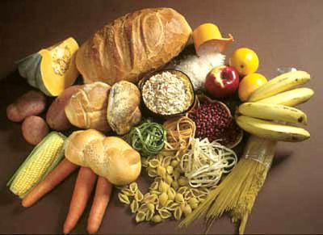

**Complex carbohydrates:** potatoes, yams, brown rice, oatmeal, veggies, fruits

**Protein:** eggs, turkey, chicken, lean cuts of beef, fish, tofu, soy

**Fats:** raw nuts and seeds (pumpkin, walnut, almond, Brazil, cashew), salmon, fish oil, flax oil, avocado.

Resource: <http://helpguide.org/>