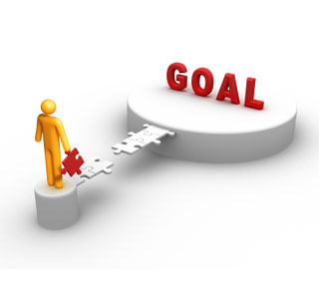 **new year, new you**

Better Health in 2012

**Week 3: Stress Reduction and Better Sleep in 2012**



“Managing stress is all about taking charge: taking charge of your thoughts, your emotions, your schedule, your environment, and the way you deal with problems.”

Healthy Ways to Relax and Recharge

|  |  |
| --- | --- |
| * Go for a walk * Spend time in nature * Call a good friend * Release tension with a good workout * Write in your journal * Take a long bath * Light scented candles | * Savor a warm cup of coffee or tea * Play with a pet * Work in your garden * Get a massage * Curl up with a good book * Listen to music * Watch a comedy |

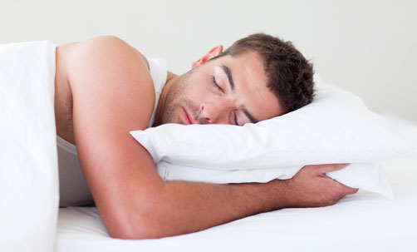

Sleep is essential for energy, health, productivity, and

emotional balance. And most people don’t get nearly enough.

Not only can poor sleep make us both mentally and physically

tired, it can also cause **weight gain**.

“**While sleep requirements vary slightly from person to person,** **most healthy adults need between 7.5 to 9 hours of sleep per night to function at their best.”**

Resource: <http://helpguide.org/>