** new year, new you**

Better Health in 2012

**INSTRUCTIONS**

EWSNetwork is here to help you achieve your wellness goals this year.

Enjoy getting back on track in 2012 by participating in the first wellness challenge of the year!

The New Year, New You Challenge begins on **MONDAY, JANUARY 23rd**.

For 3 weeks, you will receive a task card and an informative email that will focus on a different group of healthy lifestyle habits for that week.



**Week #1** will focus on incorporating some specific healthy nutritional habits into your everyday eating regiment.



**Week #2** will focus on adding some more physical activity into your day.

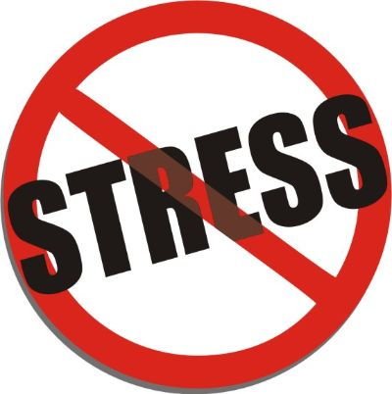 **Week #3** will focus on reducing and coping with stress in your life AND on improving the quality and quantity of sleep you get each night.



All of these habits associated with your nutrition, physical activity, stress levels and sleep play a major role in developing a healthy lifestyle.

* Complete as many healthy tasks as you can, each day, to accumulate points for your team.
* Each Monday morning, email your team captain with your point total for the previous week.
* Team captains will keep track of points.
* The team with the most wellness points at the end of the 3-week challenge WINS!