



new year, new you

**Better Health in 2012**

**Challenge Starts MONDAY,**

**Jan 16th, 2012**

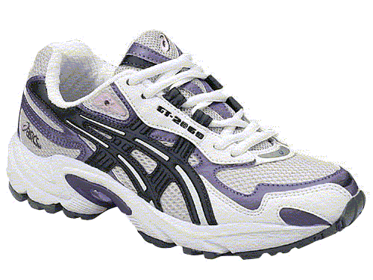

**What are your goals for 2012?**

**EWSNetwork is here to help you with your wellness goals.**

**Each week, for THREE weeks, a task card will be available to you with healthy tasks to complete – designed to help you get back on track.**

**Complete at least FOUR healthy tasks on the weekly cards provided and enter your name for prize draws.**

* **Week #1 – Better Nutrition in 2012**
* **Week #2 – Consistent Exercise in 2012**
* **Week #3 – Stress Reduction and Better Sleep in 2012**

Contact your on-site wellness consultant to make a FREE,

customized wellness appointment to discuss your goals for 2012!

**info@EWSNetwork.com**