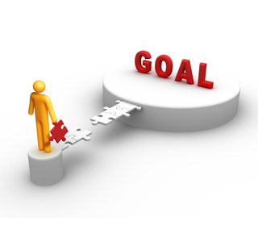 **new year, new you**

Better Health in 2012

**INSTRUCTIONS**

EWSNetwork is here to help you achieve your wellness goals this year.

Enjoy getting back on track in 2012 by participating in the first wellness challenge of the year!

The New Year, New You Challenge begins on **MONDAY, JANUARY 16th.**

For 3 weeks, you will receive a task card and an informative email that will focus on a different group of healthy lifestyle habits for that week.



**Week #1** will focus on incorporating some specific healthy nutritional habits into your everyday eating regiment.

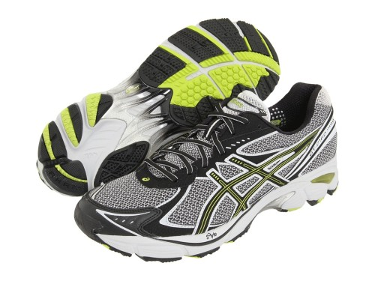

**Week #2** will focus on adding some more physical activity into your day.

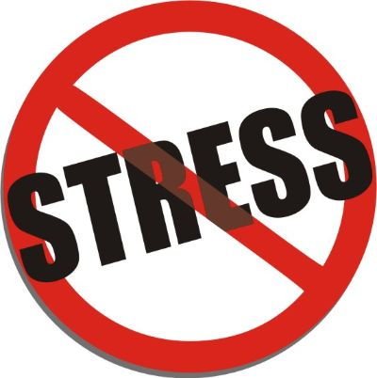

**Week #3** will focus on reducing and coping with stress in your life AND on improving the quality and quantity of sleep you get each night.

All of these habits associated with your nutrition, physical activity, stress levels and sleep play a major role in developing a healthy lifestyle.

* Once you have completed a minimum of any 4 activities on the card (does not have to be in a line), write your name and extension on the provided ballots in the designated area.
* The more tasks completed, the more chances to WIN **“New Year, New You”** prizes.
* Draws will be done randomly throughout the program.
* Good luck and have fun!