**How to be a Smart Host**

Before the Party

* Ask someone to help you if problems arise.
* Provide alcohol-free drinks like coffee, tea, pop, fruit punch and juice, along with alcoholic drinks.
* Be prepared for overnight guests by having blankets, sleeping bags and pillows on hand.

During the Party

* 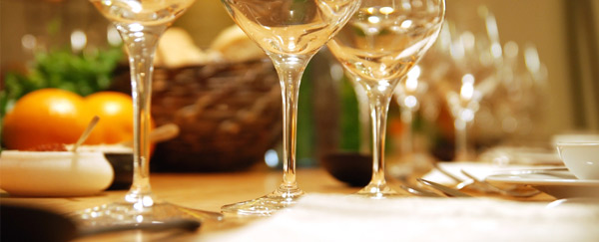Limit how much you drink yourself, so you can keep control of things.
* Mix and serve drinks yourself or appoint someone responsible as bartender. Guests tend to drink more when they serve themselves.
* Serve food, but avoid salty, sweet or greasy foods because they make people thirstier.
* Encourage guests to name designated drivers, leave their cars at home, take taxis or public transport, or walk. Keep cash and taxi numbers ready.
* Never serve alcohol to minors.

End of the Party

* Stop serving alcohol at least **an hour** before the party ends.
* Don't rely on coffee to sober guests up. It only makes them more alert, not sober.

**Risks from Long Term Drinking**

Injuries. Alcohol is a factor in:

* 60% of fatal burn injuries, drownings, and homicides
* 50% of severe trauma injuries and sexual assaults
* 40% of fatal motor vehicle crashes, suicides, and fatal falls.

Health problems.Heavy drinkers have a greater risk of:

**Fetal Alcohol Spectrum Disorder**

Drinking even a *moderate* amount of alcohol when pregnant may cause brain damage and other serous problems.

**Bottom line** – do not drink during pregnancy or when planning to become pregnant.

* liver disease
* heart disease
* sleep disorders
* depression
* stroke
* bleeding from the stomach
* sexually transmitted infections from unsafe sex
* several types of cancer

They may have problems managing diabetes, high blood pressure, and other conditions.

Alcohol use disorders.Alcoholism, alcohol abuse, and alcohol use disorders are medical conditions that doctors can diagnose when a patient's drinking causes distress or harm.

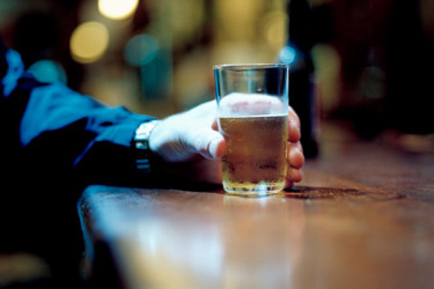

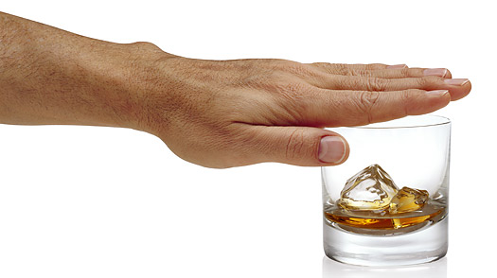

**Substance**

**Misuse**

**Prevention**

**What is Alcohol?**

Alcohol is a drug – a depressant that slows down your body’s central nervous system.

Depending on how much you drink, alcohol can affect your concentration, speech, balance, vision, coordination and judgment.

The effects of alcohol depend on many factors:

* Gender
* Body size
* How much you usually drink
* How quickly you drink
* Mood
* How much you have eaten
* Past experiences with drinking

**When Drinking Stops – Alcohol’s Effects Do Not**

Alcohol’s Effects Begin Quickly

* Initially, alcohol acts as a stimulant, making you feel upbeat.
* Soon after, inhibitions and judgment are affected leading to reckless decisions.

Alcohol’s Lasting Effects

* **Alcohol continues to affect the brain and body long after the last drink has been consumed.**
* 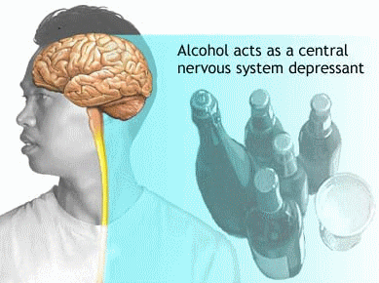Even after someone stops drinking, alcohol continues to enter the bloodstream, impairing judgment and coordination for **hours**.

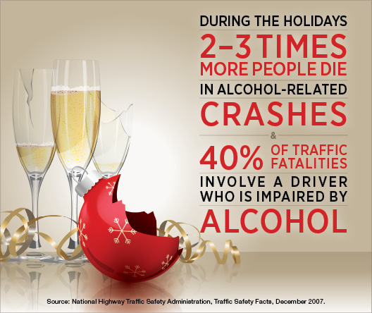

**Resources:**

<http://www.medicinenet.com/>, <http://www.hc-sc.gc.ca/>, <http://www.niaaa.nih.gov/>, <http://psychcentral.com/>

**Brought to you by:**

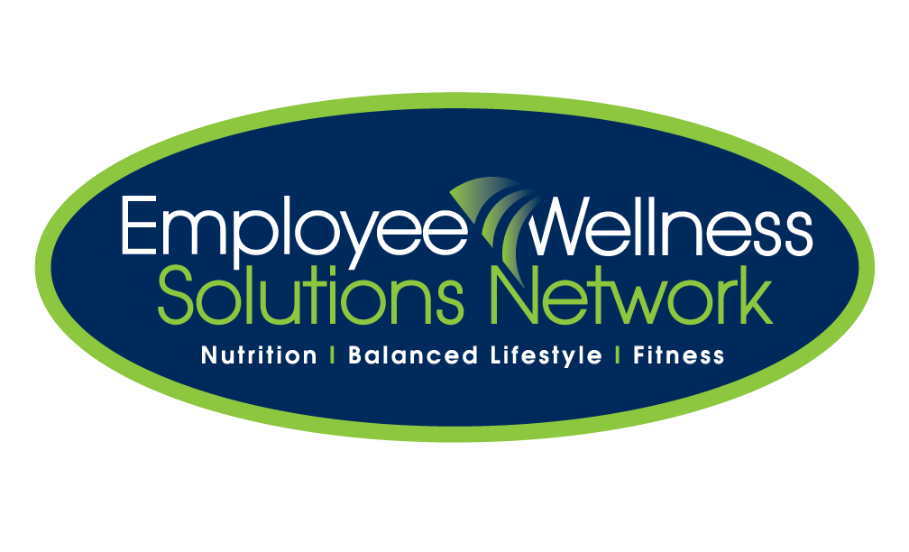

**Effects of Alcohol**

**Short Term Effects of Too Much Alcohol**

* Drowsiness
* Dizziness
* Slurred speech
* Loss of coordination skills
* Inability to think and judge clearly
* Inability to estimate distances and decreased reaction times

Myth:

Drink coffee. Caffeine will sober you up.

Fact:

Caffeine may help with drowsiness but **not** with decision-making or coordination. The body needs **time** to break down alcohol and then return to normal.

**Long Term Effects of Too Much Alcohol**

* The need to drink more to feel the same 'high'
* More money is being spent on alcohol
* Poor appetite, jumpiness, insomnia or sweating when not drinking
* Blackouts when drinking or not remembering drinking
* Bouts of confusion or memory loss

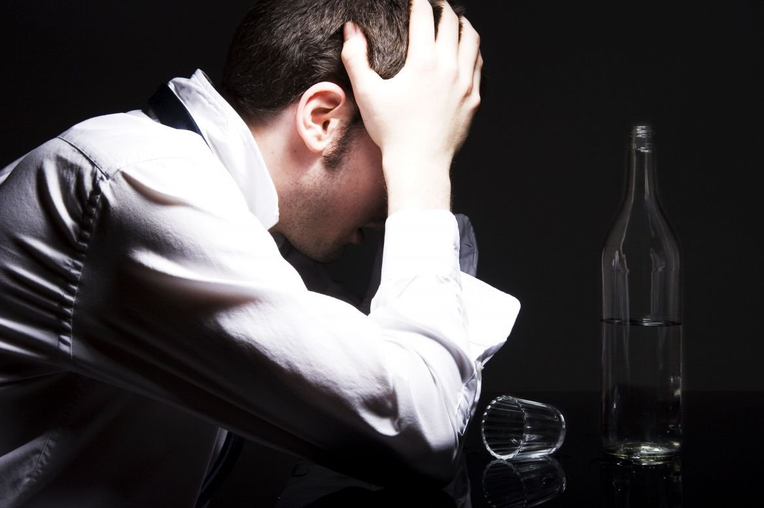

**5 Tips for Responsible Drinking**

1. Just say no.

Resist the pressure to drink or serve alcohol at every social event. Just because it’s there does not require that you drink it.

1. Swap with caffeine-free non-alcoholic beverages.

Don’t feel like you have to drink just because your host offers — it’s not rude to choose a non-alcoholic beverage instead. If you are drinking, replace your alcoholic drink with a non-alcoholic beverage every **3** hours.

1. Designate a driver before the party.

If you or your friends are going to a party and plan to use alcohol, decide in advance who will be the designated driver. Decide that drinking and driving is not an option.

**You can stop yourself before you go too far, you just need to choose to do so.**

1. Choose your number ahead of time.

If you are going to drink, decide ahead of time how many drinks you will have and stick to it. A blood alcohol content chart can help you understand the relationship between the amount of drinks, blood alcohol content and level of impairment.

1. Remember that alcohol is a complement, not the purpose.

Sometimes we lose sight of a holiday celebration or party and see it as a chance to drink socially. While it may be an opportunity, the main purpose of a party is to have fun with people you know.

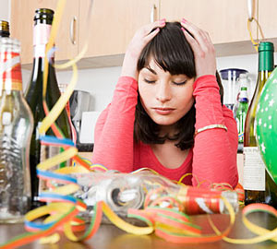

**Drinking is always an option and optional, and it is as much as a choice as it is a responsibility**.

**How much is a “drink”?**

Recommended Serving Size:

* 12 oz beer
* 5 oz wine or
* 1.5 oz liquor

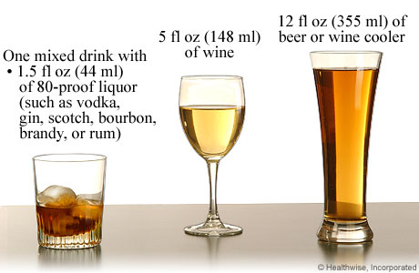

Woman should have no more than **one**drink per day and

men, **two** drinks per day.

|  |  |  |  |  |  |
| --- | --- | --- | --- | --- | --- |
| 12 fl oz of  **regular beer** | 8-9 fl oz of  **malt liquor**  (shown in a 12-oz glass) | | 5 fl oz of  **table wine** | | 3-4 oz of  **fortified wine**  (sherry or port; 3.5 oz shown) |
|  |  | |  | |  |
| about  5% alcohol | about  7% alcohol | | about  12% alcohol | | about  17% alcohol |
|  | |  | |  | | |
| 2-3 oz of  **cordial, liqueur, or aperitif**  (2.5 oz shown) | | 1.5 oz of  **brandy**  (a single jigger or shot) | | 1.5 fl oz shot of  **80-proof spirits** (hard liquor) | | |
|  | |  | |  | | |
| about  24% alcohol | | about  40% alcohol | | about  40% alcohol | | |